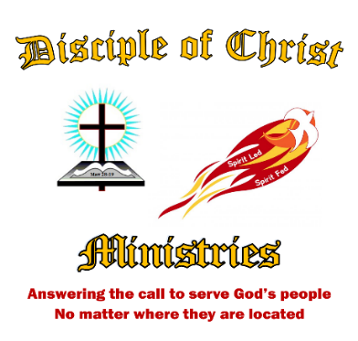**The 2nd Edition in 2021 of the**

**The Disciple Times**

273 Newport Ave Unit 2, Quincy, MA 02170

Office: 617-237-9607 ~ Prayer Line: 617-237-0019

Web: [**www.DiscipleofChristMinistries.org**](http://www.DiscipleofChristMinistries.org) & [**www.PenPalsforJesus.org**](http://www.PenPalsforJesus.org)

***Celebrating 9 Years this May***

***From the desk of Pastor Dennis***

*Dear Heavenly Father, I come before your altar today, kneeling at the foot of the cross that Jesus was nailed to for my sins. His precious blood freed us from our sins. He died, was buried and raised from the dead to sit at the right hand of your throne. You assure me that if I believe in His death and Resurrection that I will live in eternity with you, that you have laid out my path and know me by name, created in your likeness, called a child of God.*

*Father God, we need you, in our lives and as a part of our community no matter where that might be. We lift up our elected officials to you that they may fall to their knees and cry out to you for direction. That they can see beyond what is of this world and bring back stability, peace, and what is just in your eyes.*

*Father God, I ask that you open the heart, eyes and ears of those whose hands you placed this newsletter in, so they can hear your words being spoken to them. Open their eyes to see the signs you have provided for them; that they too can receive the same hope and love that I found in* ***The Valley of Dry Bones****. Help them see your presence in their own valley of dry bones. Speak new life into their souls, so they can see what you have laid before them. Give them courage as they walk alongside their peers, regardless of the color of their skin. Let them be the church, sharing the peace and joy of knowing that they are loved by You - not lost or forgotten.*

*We pray this in your Son Jesus’ precious and holy name. Amen.*

Well, here we are again – it is time for the second Newsletter of 2021. Join me as we celebrate our 9 year anniversary on May 18th. What a joy it has been since being called to serve God in Prison Ministry. I hope this issue finds you in good health and in a well-spirited place.

Dear Brothers and Sisters in Christ,

I am so grateful and thank God for placing this Ministry upon my heart. It is hard to believe it’s been 9 years since being led to form Disciple of Christ Ministries. Knowing I needed to be obedient to this calling, I gave God full authority over all things in regards to this ministry, faithfully following where the Spirit led me. I am still faithfully committed to serving God through this ministry. I continue to pray for the resources, knowledge, and wisdom to reach all people God places in our path.

As I continue to work full-time to build this ministry to meet the needs of God’s children, no matter where they are located. We have reached many milestones over the 9 years. This past year has brought a whole new meaning to evangelizing to inmates as many institutions went into lockdown. We receive new requests almost every day for pen pals, re-entry information, mentoring, and spiritual guidance.

With this ministry’s growth we are challenged by our already limited finances and lack of volunteers. We are constantly seeking new volunteers to help with our mission to spread the Gospel of Jesus Christ: where we live, work, and through Prison Ministry. Over the past year we have seen God’s hands at work, sending us new volunteers from across the country to take part in our Pen Pals for Jesus ministry. A prayer answered!

There are so many amazing things that have brought me to realize how blessed I am through this ministry. I am forever grateful to all who have kept me going over the past nine years. Thank you to each and every person who has given your time in writing to our inmates, your financial support, and the wisdom to make our efforts possible.

Through our efforts in outreach ministries we have been able to make a positive impact on the lives of many of God’s people who have chosen to walk with Christ, by sharing our own testimonies of how God has used our trials and tribulation for His glory. We may not have a church building standing in one location - that is not what God wanted for us. We have something much bigger and better than a building, we have our website which has no limit to how far we can reach. We have been able to reach throughout the United States and beyond. I have invested in building a strong foundation for this ministry, knowing that if it was of God, the ministry would reach those lost souls seeking a life in Christ, becoming faithful servants.

Praise God, we are still reaching the lost and forgotten for Christ. All because I called out to God asking Him to take my life as I no longer wanted to live. Hearing a voice in the middle of the night; “oh you wanted me to take your life well you need to get up and follow me”.

**In Acts 5:38-39 a Pharisee named Gamaliel, a teacher of the law, said:**

**Therefore, in the present case I advise you: Leave these men alone! Let them go! For if their purpose or activity is of human origin, it will fail. But if it is from God, you will not be able to stop these men; you will only find yourselves fighting against God."**

Here are a few of our major accomplishments over the past nine years:

◻ We have had over 920,000 hits on our website.

◻ We are now reaching just over 300 inmates in 37 States through our Pen Pals for Jesus Ministry.

◻ We sent out over 2,000 greeting cards. *(Birthday, Holiday, Thinking of you)*

◻ We published and mailed over 6,300 Newsletters, over the past 9 years, which include Bible Studies and faith building lessons.

I hope that you find this newsletter uplifting and inspirational. It is our goal to bring new life to those who were considered an outcast, a drug addict, a murderer, and most important to us, the forgotten souls. “For I was in prison and you did not visit me”. It has been my passion to visit those who are in prison with inspirational stories of what God is doing in our lives. One thing I know for sure: you don’t need to be behind the wall to be in prison. So many of us are still in bondage with sin. We would love to share your testimonies in future issues. Please feel free to submit your stories of how you found Christ’s grace and mercy while serving time.

While I was gathering information for this newsletter I was reminded how I had gotten to this point in my journey and was led to Ezekiel 37:1-14 “The valley of dry bones”. In this issue I also wanted to incorporate more of how my own walk with Christ changed me. The decision to follow God after my release was not an easy choice but I committed to following the path the Holy Spirit had laid out for me. I am so grateful I followed the Holy Spirit in leading me to a Bible teaching church, where I would hear God speaking life into my soul. As I was taking part in a Bible study in April of 2012 I was reminded that I was called to serve in ministry. Confirmation and one of my first signs that I needed to be obedient to God outside the wall.

Throughout my own time spent behind the wall, God would speak to me through people, perhaps just like Ezekiel spoke God’s Words to those dry bones in the valley. I had a Christian Brother named Jake who would come into my unit every Monday night for a Bible Study, never judging any of us who attended, and very helpful on my own walk in finding Christ.

One thing I’ll never forget is that when I asked Jake what he did wrong that God had him coming into a prison for a Bible Study. His reply was, “Well, Doc I’ll tell you; it is because God wanted me to tell you he loves you!”

I can clearly see now that I was among those dry bones, needing to be put back together, thinking my life was over and having given up on myself. Through hearing God’s words being spoken to me during Jake’s Bible Studies, I started to feel my body coming alive again. My soul wanted more, so I started seeking out more about God, praying daily for spiritual guidance.

Then along came a Christian Brother named Jonathan who also is a major factor in my walk with Christ. He would spend time going through the New Testament with me, teaching me to be open to the Holy Spirit, so I would understand my God given gifts. I am here to say God does breathe a new spirit into our broken sinful bodies and raises the lost souls from the lowest valleys. As it was written in the Bible, like Matthew 27:50-53

***And when Jesus had cried out again in a loud voice, he gave up his spirit. At that moment the curtain of the temple was torn in two from top to bottom. The earth shook and the rocks split. The tombs broke open and the bodies of many holy people who had died were raised to life. They came out of the tombs, and after Jesus' resurrection they went into the holy city and appeared to many people***

Where are you today? Are you just dry bones laying in a dark cold valley with all the other dry bones? Perhaps you’re just at the very beginning where God spoke through Ezekiel saying I will attach tendons to you and make flesh come upon you and cover you with skin. Or are you just waiting for God to send you a person to breathe the Spirit into your own soul? Even better, are you called to be like Ezekiel, is God asking you to walk into the valley of dry bones so you can prophesy to the dry bones before you? Wherever you may presently be, know that you can be a voice for God’s. Show people around you Gods craftsmanship working in your life with your actions, displaying how God has changed your life, no matter where you are located.

I look forward to hearing from you no matter if you’re behind the wall or one of the many people who receive our newsletter, with your suggestion for articles, “Bible Study Topics” or sharing your testimonies for upcoming newsletters.

I would like to thank all my Christian friends for making it possible for this issue by their support, encouragement, and funding. A special thanks to my home church Reunion Christian Church for their generous donation. Also a thank you to the Weymouth Rotary Club for their donation and for allowing me to share the work of this ministry with them at a recent monthly meeting.

Forever in His Grace,

Dennis Dockham

***The Valley of Dry Bones***

***Ezekiel 37:1-14 (NIV)***

1 The hand of the LORD was upon me, and he brought me out by the Spirit of the LORD and set me in the middle of a valley; it was full of bones. 2 He led me back and forth among them, and I saw a great many bones on the floor of the valley, bones that were very dry. 3 He asked me, "Son of man, can these bones live?" I said, "O Sovereign LORD, you alone know." 4 Then he said to me, "Prophesy to these bones and say to them, 'Dry bones, hear the word of the LORD! 5 This is what the Sovereign LORD says to these bones: I will make breath enter you, and you will come to life. 6 I will attach tendons to you and make flesh come upon you and cover you with skin; I will put breath in you, and you will come to life. Then you will know that I am the LORD.' " 7 So I prophesied as I was commanded. And as I was prophesying, there was a noise, a rattling sound, and the bones came together, bone to bone. 8 I looked, and tendons and flesh appeared on them and skin covered them, but there was no breath in them. 9 Then he said to me, "Prophesy to the breath; prophesy, son of man, and say to it, 'This is what the Sovereign LORD says: Come from the four winds, O breath, and breathe into these slain, that they may live.' " 10 So I prophesied as he commanded me, and breath entered them; they came to life and stood up on their feet--a vast army. 11 Then he said to me: "Son of man, these bones are the whole house of Israel. They say, 'Our bones are dried up and our hope is gone; we are cut off.' 12 Therefore prophesy and say to them: 'this is what the Sovereign LORD says: O my people, I am going to open your graves and bring you up from them; I will bring you back to the land of Israel. 13 Then you, my people, will know that I am the LORD, when I open your graves and bring you up from them. 14 I will put my Spirit in you and you will live, and I will settle you in your own land. Then you will know that I the LORD have spoken, and I have done it, declares the LORD.' "

**Our Bible Study**

### **THE VALLEY OF DRY BONES**

### **(Ezekiel 37:1-14)**

***Introduction:***

The Old Testament was written for our learning (Romans 15:4).

God has taught many wonderful lessons in some rather unusual ways.

1. Hosea was told to marry a harlot (Hosea 1:2).
2. Naaman was told to dip in the Jordan (II Kings 5:10).
3. Moses was told to make a brazen serpent (Num. 21:4-9).
4. Ezekiel was told to lay on his left side for 390 days (Ezekiel 4:4-8).

***Ezekiel 37*** introduces us to another rather unusual lesson that God taught through the prophet Ezekiel.

This lesson is designed to ascertain several lessons from Ezekiel's experience.

**THE HISTORICAL BACKDROP. (Ezekiel 37:1-14).**

* Ezekiel was taken into a valley full of dead men's bones.
* God asked Ezekiel if those bones could live.
* Ezekiel's response was, "O, Lord God, You know."
* God then instructed Ezekiel to go preach to those bones.
* When Ezekiel did as commanded, the bones took on ligaments, muscles, and flesh.
* After preaching more, the bodies became alive again.
* Contextually, the point of this experience was to inform Israel that God could raise them up out of their spiritual graves and restore life to them once again.

***PRACTICAL LESSONS FROM (EZEKIEL 37)***

**A. *One Needs To Obey God, Regardless.***

1. Ezekiel's instruction did not seem to be a very rational thing to do.
2. But God commanded it, and it needed to be obeyed.
3. There are yet many commands that give people problems today because they seem to lack explanation.
4. Baptism (Acts 2:38).
5. The Cross (I Corinthians 1:18).
6. The Lord's Supper (Mark 14:22-25).
7. It is not within a man to direct his own steps. (Jeremiah 10:23)
8. God's ways are not always our ways. (Isaiah 55:8-9)

***B. Nothing Is Impossible With God.***

1. There is no hopelessness with God.
2. Ezekiel preached to a bunch of dry bones and was successful.
3. We need to preach and let the gospel do its work (Romans 1:16).
4. We are to plant and water while God will take care of the growth. (I Corinthians 3:5-6)
5. Look at what God did with Paul (Acts 22:3-5).

***C. Ezekiel Preached What He Was Told To Preach.***

1. "I Prophesied as I was commanded..." (Ezekiel 37:7)
2. "Preach the preaching I bid you..." (Jonah 3:2)
3. Would they have had results if they had preached something else?
4. Preach the "Word". (II Timothy 4:1-5)
5. A "watered-down" gospel that appeals to social and recreational concerns will not convert the lost.
6. Speak the oracles of God. . (I Peter 4:11)

***D. There Is A Need For Self Examination.***

1. Could we be like those dead, dry bones of Ezekiel?
2. Could we look alive outwardly, but in reality be dead (Rev. 3:1)?
3. Israel was dead in their graves, but was promised revival by God if they turned back to Him.
4. This is exactly the message that is needed today.
5. Remember, Repent, and Return (Revelation 2:5).

***Conclusion:***

1. We have a seemingly impossible task today, much like that of Ezekiel.

2. We have been told to go preach the gospel of Christ to a dead world.

3. May this lesson inspire us to do our part, and the power of God's word will do the rest.

***Some scripture I hope will help guide you along the way in your journey through your valley of dry bones.***

(**Romans 15:4)** For everything that was written in the past was written to teach us, so that through endurance and the encouragement of the Scriptures we might have hope.

**(Hosea 1:2)** When the LORD began to speak through Hosea, the LORD said to him, "Go, take to yourself an adulterous wife and children of unfaithfulness, because the land is guilty of the vilest adultery in departing from the LORD."

(II Kings 5:10) Elisha sent a messenger to say to him, "Go, wash yourself seven times in the Jordan, and your flesh will be restored and you will be cleansed."

**(Num. 21:4-9)** 4 They traveled from Mount Hor along the route to the Red Sea, to go around Edom. But the people grew impatient on the way; 5 they spoke against God and against Moses, and said, "Why have you brought us up out of Egypt to die in the desert? There is no bread! There is no water! And we detest this miserable food!" 6 Then the LORD sent venomous snakes among them; they bit the people and many Israelites died. 7 The people came to Moses and said, "We sinned when we spoke against the LORD and against you. Pray that the LORD will take the snakes away from us." So Moses prayed for the people. 8 The LORD said to Moses, "Make a snake and put it up on a pole; anyone who is bitten can look at it and live." 9 So Moses made a bronze snake and put it up on a pole. Then when anyone was bitten by a snake and looked at the bronze snake, he lived.

**(Ezekiel 4:4-8)** 4 "Then lie on your left side and put the sin of the house of Israel upon yourself. You are to bear their sin for the number of days you lie on your side. 5 I have assigned you the same number of days as the years of their sin. So for 390 days you will bear the sin of the house of Israel. 6 "After you have finished this, lie down again, this time on your right side, and bear the sin of the house of Judah. I have assigned you 40 days, a day for each year. 7 Turn your face toward the siege of Jerusalem and with bared arm prophesy against her. 8 I will tie you up with ropes so that you cannot turn from one side to the other until you have finished the days of your siege.

**(Acts 2:38)** Peter replied, "Repent and be baptized, every one of you, in the name of Jesus Christ for the forgiveness of your sins. And you will receive the gift of the Holy Spirit.

**(I Corinthians 1:18)** For the message of the cross is foolishness to those who are perishing, but to us who are being saved it is the power of God.

**(Mark 14:22-25)** 22 While they were eating, Jesus took bread, gave thanks and broke it, and gave it to his disciples, saying, "Take it; this is my body." 23 Then he took the cup, gave thanks and offered it to them, and they all drank from it. 24 "This is my blood of the covenant, which is poured out for many," he said to them. 25 "I tell you the truth, I will not drink again of the fruit of the vine until that day when I drink it anew in the kingdom of God."

**(Jeremiah 10:23)** I know, O LORD, that a man's life is not his own; it is not for man to direct his steps.

**(Isaiah 55:8-9)** "For my thoughts are not your thoughts, neither are your ways my ways," declares the LORD. 9 "As the heavens are higher than the earth, so are my ways higher than your ways and my thoughts than your thoughts.

**(Romans 1:16)** I am not ashamed of the gospel, because it is the power of God for the salvation of everyone who believes: first for the Jew, then for the Gentile.

**(I Corinthians 3:5-6)** What, after all, is Apollos? And what is Paul? Only servants, through whom you came to believe--as the Lord has assigned to each his task. 6 I planted the seed, Apollos watered it, but God made it grow.

**(Acts 22:3-5)** "I am a Jew, born in Tarsus of Cilicia, but brought up in this city. Under Gamaliel I was thoroughly trained in the law of our fathers and was just as zealous for God as any of you are today. 4 I persecuted the followers of this Way to their death, arresting both men and women and throwing them into prison, 5 as also the high priest and all the Council can testify. I even obtained letters from them to their brothers in Damascus, and went there to bring these people as prisoners to Jerusalem to be punished.

**A further look into Ezekiel 37**

How does this relate to today’s times?

A study by Pastor Dennis

**Ezekiel was shown a valley of Dry Bones** that represent the condition of Israel in captivity in Babylon. *I was also shown a valley of dry bones! These are the days of my coming to the realization that my soul was no longer mine but of a hardened heart: living in bondage to the earthly ways in sin, living in total darkness, calling out to God to take my life as I no longer wanted to live.*

This is what the vision means.....

[Ezekiel 37:11 NLT](https://biblia.com/bible/nlt/Ezek%2037.11)

Then he said to me, “Son of man, these bones represent the people of Israel. They are saying, ‘We have become old, dry bones—all hope is gone. Our nation is finished.’ *Have you become old, dry bones? When I was sitting in a cell still calling out for God to take my life. I heard a voice in the whispering wind saying to me. “So you still want me to take your life then get up and follow Me!”*

**The Dry bones represent a time of utter hopelessness**

It was a situation beyond their ability to see any solution for. *Maybe you can relate to this, just as I still can remember! I was at my lowest point in my life in a state of hopelessness. We are in dark times, and many struggle to see the end of the unrest in the world. However, we have a loving God who will speak life into your soul.*

**Yet a few things are made clear about what is needed in a time like this.**

God commands **Ezekiel to prophesy to the bones**. *Well, God commanded Jake, the Christian Brother I mentioned in my opening message. He was called to serve God in teaching God’s Word inside the walls of the correctional institution where I was housed about 10 years before I ever arrived.*

*In my eyes he was sent to speak life into my dead dry bones. Jake has been like a brother to me since my release and I still visit with him at a Bible study he has in his shop.*

*We as born again Christians are the ones who need to profess our testimonies to those who cannot see the Light of Christ in their own lives.*

**Ezekiel 37:4 NLT**

Then he said to me, “Speak a prophetic message to these bones and say, ‘Dry bones, listen to the word of the Lord! *We need to speak life into those who have become lost and feel hopeless. We have new life in the Word of God, we need to share the word to all around us. Speak life into those who still feel dead inside the walls of your institution.*

**Sometimes God asks us to say & do things that seem ridiculous.**

God asked Ezekiel **if the situation could be fixed.**

Ezekiel said...”**you alone know the answer to that”**

**Ezekiel takes a chance and goes along with this seemingly crazy request from God....** *In the very beginning of this journey of mine I was like, “Are you sure this is what you really want me to do?” In my eyes I thought, “Who am I, and what could I do?” Well, I am so glad I did not let that stop me. I eventually figured it out that if this was of God I could do anything through Him.*

**Some things to look at:**

**1) God told Ezekiel** what to say and do *(speak to the bones)*

Who owns the hands that do God’s work on the earth..? *(We do)*

Who owns the feet that bring good news…? *(We do)*

Who has the tongue through which God blesses and commands…? *(We do)*

We need to listen to God’s directions.

**A Scripture***brought to life in your own trials could shine light for someone else.*

**A still small voice while praying or talking with God.** *I can still hear the whispering wind in my ear calling me to walk with Christ while sleeping in my cell. I have continued to allow time to be still and listen to what the Spirit is saying to me.*

**A picture or a word can be given as God’s direction.** *Looking back over the last 13 years since turning my life over to God. I can clearly remember God addressing my doubt in what I was hearing, what He was calling me to do. They may be big things or very small things - I just need to keep my heart open and my mind clear.*

**If we do not practice listening for God’s direction we will make a mess of it**. *Believe me when I say this, I have made many mistakes and tried to do things my way over the years of this ministry. However, I would get subtle hints about what God wanted me to do. It only took me 8 months after my release when I finally took hold of God’s words spoken to me in a vision. And that is when Disciple of Christ Ministries was founded.*

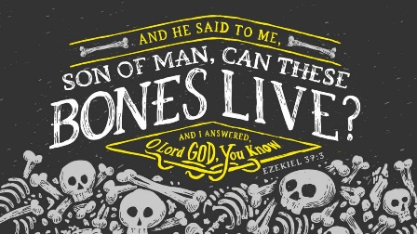

***Verse 7 says***

**So I spoke this message, just as he told me. Suddenly as I spoke, there was a rattling noise all across the valley.** *Well, as I began my journey in ministry I guess you can say that I heard a rattling in my head. I am sure many of you can understand this: doubts, insecurity, and fear can really take hold of your soul.*

**2) Ezekiel obeyed God without argument or hesitation.** *Well, I can say that I did not argue about what God had called me to do. However, I sure did hesitate of what he was asking me to do. So glad I allowed the Holy Spirit to lead the way.*

**Don’t ask God for direction without the decided mind to obey.** *Many times over the past 9 years I have asked God for direction and wisdom. Every time I have had a need to fulfill His plan, He provided the resources.*

**Decide before you pray that whatever God says, you will do.** *Don’t ask for what you will not do. This ministry was given to me in a vision while serving time. Not thinking I was good enough, I knew that if I continued to pray for guidance and wisdom things would be done in His will, not mine. When I pray and ask God for something, I know I’d better prepare myself for how and when He’ll answer.*

**Summary so far**

a) **Listen to God**

*Prayer - bible- confirmation from others are just a few ways you might receive God’s words for you.*

b) **Obey what he says to do or speak.** *I sometimes think back at what if I didn’t follow what God was asking me to do. I am so glad I chose to follow his plan for me.*

c) **Then the Miracle happens.**

*The miracle is when God takes over just as*

*Ezekiel needed to step out of the way and just watch God work. So do we!*

**Children gone astray**

*Ask God what to do or say*

*Then step back and let God work*

**Marriage in trouble**

*Ask God what to do or say*

*Then step back and let God work*

**Career roadblock or challenge**

*Ask God what to do or say*

*Then step back and let God work*

**Issues of becoming like Christ**

*Ask God what to do or say*

*Then step back and let God work.*

*God put the dry bones and bodies back together, not us.*

God **outwardly fixed the situation** - but there was **one more thing needed:**

**God’s breath!**

***This is what the Sovereign Lord says: Look! I am going to put breath into you and make you live again!***

**God’s breath** made them **stand** on their feet and become a **great army.**

**What is God’s breath?**

**Hebrew word is RUACH**

“Wind, breath, air, spirit.”

[Job 34:14–15 NLT](https://biblia.com/bible/nlt/Job%2034.14%E2%80%9315)

If God were to take back his spirit and withdraw his breath, all life would cease, and humanity would turn again to dust.

This speaks of **life - being a living soul**…God gives that.

***God’s breath is so powerful that he breathed into Adam and humanity has been releasing it through procreation ever since.***

But in order to **become part of the great army of God**....to **fulfill your true purpose in life**

Something else is needed.

Jesus proved this to us.....

[John 20:21–22 NLT](https://biblia.com/bible/nlt/John%2020.21%E2%80%9322)

Again he said, “Peace be with you. As the Father has sent me, so I am sending you.” Then he breathed on them and said, “Receive the Holy Spirit.

The **human body needs breath of life**, the human spirit, **to live**

But your **human spirit needs the Breath of God**, the **Holy Spirit**, **to live**

[John 3:5–7 NLT](https://biblia.com/bible/nlt/John%203.5%E2%80%937)

Jesus replied, “I assure you, no one can enter the Kingdom of God without being born of water and the Spirit. Humans can reproduce only human life, but the Holy Spirit gives birth to spiritual life. So don’t be surprised when I say, ‘You must be born again.’

**Again we see** there is **another kind of life** that God wants to give humanity:

Spiritual Life…eternal life.

[John 11:25–26 NLT](https://biblia.com/bible/nlt/John%2011.25%E2%80%9326)

Jesus told her, “I am the resurrection and the life. Anyone who believes in me will live, even after dying. Everyone who lives in me and believes in me will never ever die. Do you believe this, Martha?”

Jesus refers to it in another way…Abundant

[John 10:10 ESV](https://biblia.com/bible/esv/John%2010.10)

The thief comes only to steal and kill and destroy. I came that they may have life and have it abundantly.

Whatever you are going through

Whatever miracle is needed

Whatever the impossible situation you are in or are seeing

The **Breath of God**, which is the **Spirit of God,** which comes to us through the **Son of God** is the only answer.

There are many different stories in the Bible where God has used some real characters to bring light to situations of great importance - from Genesis to Revelations you will find them. Where might you fall in the plans He has for you?

**Ministry update:**

I would like to thank our new Pen Pals for Jesus volunteers who have found us through our website since our last newsletter. Betty, Chad, Cheryl, Dyan, Gary, Grace, Janice, Jennifer, Joan,

Candy, Kathryn, Kevin, Kristi, Lisa, Myra, Rosemary, Sherry, Susie, and Victor.

I must remind everyone that this ministry is not a dating service. The sole purpose of Pen Pals for Jesus is to match a Christian Inmate to a volunteer Christian Man or Woman on the outside to build both the inmate’s and volunteer’s walk with Christ.

The mission is to share our walk with others, hopefully bringing a sense of God’s love for each of us inside and outside of the wall.

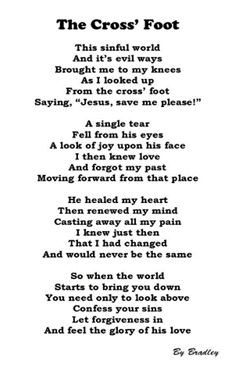

I try my very best to match up individuals who have chosen to be followers of Christ. I wish I could write to more of you to share my passion in serving God. However, with 325 inmates requesting a pen pal and not being able to fill every request, the Newsletter was started to make sure everyone would at least receive something at mail call.

I am going to leave you with a scripture that helped me in my walk with Christ, giving me the faith and courage to turn my life over to ministry work.

***1-Timothy 1:12-17***

**Christ Jesus Came to Save Sinners**

*I thank him who has given me strength, Christ Jesus our Lord, because he judged me faithful, appointing me to his service, though formerly I was a blasphemer, persecutor, and insolent opponent. But I received mercy because I had acted ignorantly in unbelief, and the grace of our Lord overflowed for me with the faith and love that are in Christ Jesus. The saying is trustworthy and deserving of full acceptance, that Christ Jesus came into the world to save sinners, of whom I am the foremost. But I received mercy for this reason, that in me, as the foremost, Jesus Christ might display his perfect patience as an example to those who were to believe in him for eternal life. To the King of the ages, immortal, invisible, the only God, be honor and glory forever and ever. Amen.*

*The Holy Bible: English Standard Version. (2016). (1 Ti 1:12–17). Wheaton, IL: Crossway Bibles.*



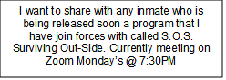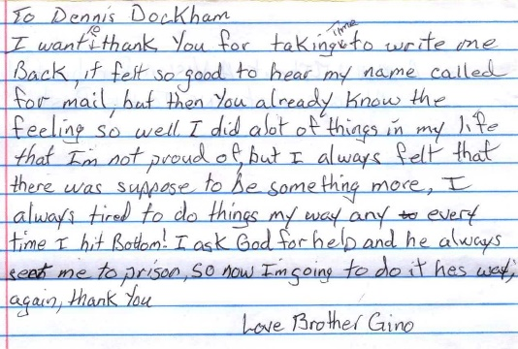Some letters from inmates

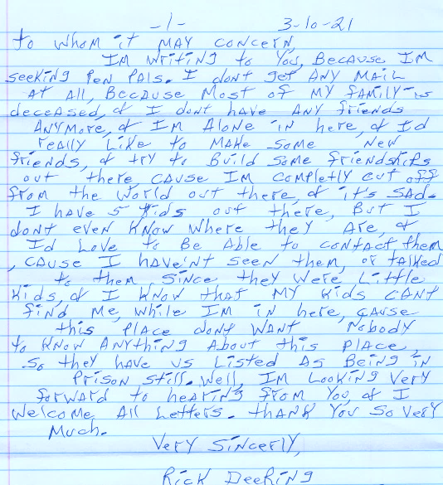

Here are some of the messages we have received from new volunteers through our website. All saying they were led to our website by the Holy Spirit!

* Hello there. I have felt led by the Lord to use my spiritual gift of encouragement to write to individuals who could use some. I looked at your website and was thrilled to discover that your statement of faith matches my own! I would love to be matched to an inmate who I could minister to through the written word. Thank you for your consideration. I am looking forward to what the Holy Spirit will accomplish.
* The Lord laid it on my heart to reach out to the prison walls
* I am excited to encourage and guide someone in their walk with The Lord!
* About 3 weeks ago while doing my morning Bible reading, God laid on my heart to write to prisoners. So I have been researching different programs and came across this one which seems to be a wonderful one.
* 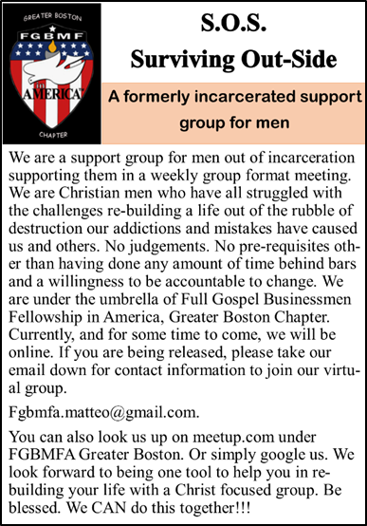I have been a Christian for over 30 years. I am looking forward to becoming a pen pal to help and encourage someone in their walk with Christ.
* I have wanted to do this for many years; upon reading your comments, now more than ever.
* My son recently has gotten himself right with God and is very hungry for knowledge about our Lord and someone to discuss it with him. He has asked me to look into pen pals and I came across your site. Thank you for any help in this matter. God's blessings on you and your project. Thank you.

***“The harvest is plentiful, but the workers are few.”*** Matthew 9:37.

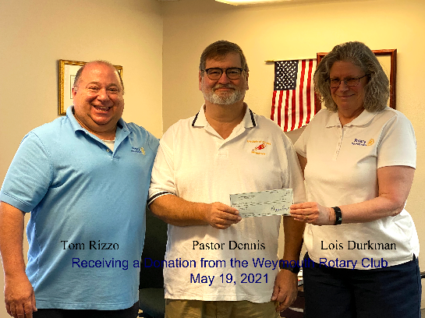We are constantly in need of more pen pal volunteers. At this moment, we have over 300 applications from inmates waiting in our office for volunteers to begin writing them. Some of our volunteers are writing more than one inmate because we just do not have enough help. God is truly bringing in a harvest through this ministry and we need workers to help bring in the harvest!

If you think you might be interested in helping in this area of our ministry, please contact me at 617-237-9607 or send us an email: office@DiscipleofChristMinistries.org

*Tom Rizzo and Louis Durkman of the Weymouth Rotary Club handing me a donation check on May 19, 2021*

*For our Pen Pals for Jesus Ministry*

***\*\*NO Phone Calls from Inmates Please.)** We cannot accept collect calls!***



**We now offer a prayer hour on Thursday’s. ~ Come join us on Zoom!**



***Answering the call to serve God’s People no matter where they are located!***

***Celebrating our 9 year Anniversary***

***Incorporated May 2012***

**Question:** ***"What is the meaning of the Valley of Dry Bones in Ezekiel 37?"***  
  
**Answer:**

Ezekiel’s vision of the valley of dry bones (Ezekiel 37:1-14) came to him after God had directed him to prophesy the rebirth of Israel in chapter 36. God had just announced, through the prophet, that Israel will be restored to her land in blessing under the leadership of “David, My servant [who] shall be king over them” (Ezekiel 37:24), clearly a reference to the future under Jesus Christ the Messiah, descendant of David (Isaiah 7:14, 9:6-7; Luke 1:31-33). However, this seemed remote in light of Israel’s present condition. She was “dead” as a nation, deprived of her land, her king and her Temple. She had been divided and dispersed for so long that unification and restoration seemed impossible. So God gave Ezekiel the vision of the dry bones as sign.  
  
God transported Ezekiel—probably not literally, but in a vision—to a valley full of dry bones and directed him to speak to the bones. Ezekiel was to tell the bones that God would make breath enter the bones and they would come to life, just as in the creation of man when He breathed life into Adam (Genesis 2:7). Ezekiel obeyed, the bones came together, flesh developed, skin covered the bones, breath entered them and they stood up in a vast army. This vision symbolized the whole House of Israel that was then in captivity. Like unburied skeletons, the people were in a state of living death, pining away with no end to their judgment in sight. They thought their hope was gone and they were cut off forever. The surviving Israelites felt their national hopes had been dashed and the nation had died in the flames of Babylon’s attack with no hope of resurrection.   
  
The reviving of the dry bones signified God’s plan for Israel’s future national restoration. The vision also, and most importantly, showed that Israel’s new life depended on God’s power and not the circumstances of the people. Putting “breath” by God’s Spirit in the bones showed that God would not only restore them physically but spiritually as well. The Israelites residing in Palestine today are not the fulfillment of this prophecy. It will be fulfilled when God re-gathers believing Israelites to the land (Jeremiah 31:33, 33:14-16) and Christ returns to establish His Millennial Kingdom (Matthew 24:30-31).

273 Newport Ave Unit 2

Quincy, MA 02170-1727