The 3rd Edition of 2021 of the
The Disciple Times
273 Newport Ave Unit 2, Quincy, MA 02170
Office: 617-237-9607 ~ Prayer Line: 617-237-0019
Web: www.DiscipleofChristMinistries.org & www.PenPalsforJesus.org
Celebrating 9 Years of Service

From the desk of Pastor Dennis

Dear Heavenly Father, I come before your altar today, kneeling at the foot of the cross that Jesus was nailed to for my sins. His precious blood freed us from our sins. He died, was buried and raised from the dead to sit at the right hand of your throne. You assure me that if I believe in his death and Resurrection that I will live in eternity with you, that you have laid out my path and know me by name, created in your likeness, called a child of God.

Father God, we need you in our lives more than ever before, and as a part of our community, no matter where that might be. We lift up our elected officials to you that they may fall to their knees and cry out to you for direction, that they can see beyond what is of this world and bring back stability, peace, and what is just in your eyes. Heal the sick, feed the hungry, and free the prisoner from his or her bondage.

Father God, I ask that you open the heart, eyes and ears of those whose hands you placed this newsletter in, so they can hear your words being spoken to them. Open their eyes to see the signs you have provided for them; that they too can receive the same love and unity you shared with us in the story of the Woman at the Well. Help them see your presence in their own place of uncertainty. Speak Living Water into their hearts, so they can experience what you have laid before them. Give them courage to cross the cultural boundaries as they walk alongside their peers, regardless of the color of their skin or nationalities. Let them be like the Samaritans who, after spending two days with Jesus, believed in him for the words he spoke to them. Give them the guidance to be the church, sharing the peace and joy of knowing that they are loved by you - not lost or forgotten.

We pray this in your Son Jesus’ precious and holy name. Amen.

Dear Brothers and Sisters in Christ,

I hope this issue finds you in good health and in a well-spirited place. First I would like to thank all those who responded to me about the message of The Valley of Dry Bones in the last newsletter. I am so glad that this message had touched your hearts and sparked some rebirth in your daily walk. What encouragement to hear back from individuals who said that my messages are getting deeper and more focused. All the glory to God for these messages as I seek what He wants me to write.
A lot has happened since the last newsletter here and around the world. Just as we think the pandemic has slowed down it sparks its nasty bite back upon us. I do not know if you are one who has been vaccinated or not. I just pray that God protects you from this latest Delta version of COVID.
So, I have been busy here trying to keep up with all the new requests coming into the ministry over the past 3 months. In July alone we had 37 new inmates added to our list. We have also had a large number of volunteer writers find our ministry on the internet - all while I was dealing with a shoulder injury that sent me to PT 3 times a week. Then I had back issues that pretty much disabled me for a couple of weeks. I guess my age is starting to show however, I have God in my life and believe in the power of prayer. This too shall pass.
When I started to think about this edition of the newsletter, as always I prayed about what message God wants me to give in this edition. When I was praying I felt the Holy Spirit direct me to the story of the Samaritan woman and how this was a very important moment in the beginning of Jesus’ ministry.
I started looking at the message and trying to understanding what the message said and how it related to my journey. I still did not clearly see the message God wanted me to share. I once again went into prayer to see if this was the right message to give. The very next day at my weekly community group, the topic of the Samaritan Woman at the well came up in discussion. Then while I attended a funeral service a few days later the topic of the Samaritan woman was mentioned as the deceased’s favorite story in the Bible.
I don’t know about you, but there’s no such thing as coincidences in my book. This was truly a confirmation of what I was to talk about in this edition of the Disciple Times. It is no surprise that the message would be about how God loves us in spite of our bankrupt lives. God values us enough to actively seek us, to welcome us to intimacy, and to rejoice in our worship. As a result of Jesus’ conversation, only a person like the Samaritan woman, an outcast from her own people, could understand what this means. To be wanted, to be cared for when no one, not even herself, could see anything of value in her—this is grace indeed - meeting us just where we are.
This meeting between Jesus and the Woman at the well happened only by God the Father. This was not just by chance, as there are too many different parts to this meeting as you will see in my study; “A further look into the Woman at the well”.
One thing that I know and am very thankful for today is that God met me right in that prison cell, in all of my shame and brokenness. I will never be perfect here on Earth but one day I will be in paradise with Christ.
So as I continue my work here in ministry, by spreading the Good News to the lost and forgotten souls no matter where they are located. I’ll keep my focus on what God has done for me up to now and continue to share His word to bring love and hope to those who need Christ in their lives.
May God’s blessing be with you and keep you.
Dennis
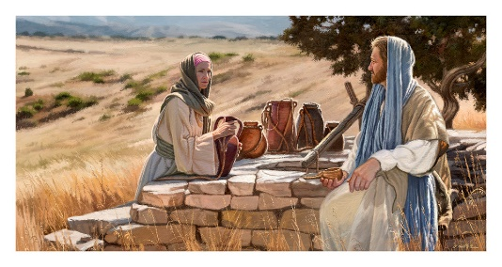
The message that broke barriers then and still can today!

Christ Witnesses to the Woman at the Well (John 4:1-26)
Therefore, when the Lord knew that the Pharisees had heard that Jesus made and baptized more disciples than John ² (though Jesus Himself did not baptize, but His disciples), ³ He left Judea and departed again to Galilee. ⁴ But He needed to go through Samaria.
⁵ So He came to a city of Samaria which is called Sychar, near the plot of ground that Jacob gave to his son Joseph. ⁶ Now Jacob’s well was there. Jesus therefore, being wearied from His journey, sat thus by the well. It was about the sixth hour.
⁷ A woman of Samaria came to draw water. Jesus said to her, “Give Me a drink.” ⁸ For His disciples had gone away into the city to buy food.
⁹ Then the woman of Samaria said to Him, “How is it that You, being a Jew, ask a drink from me, a Samaritan woman?” For Jews have no dealings with Samaritans.
¹⁰ Jesus answered and said to her, “If you knew the gift of God, and who it is who says to you, ‘Give Me a drink,’ you would have asked Him, and He would have given you living water.”
¹¹ The woman said to Him, “Sir, You have nothing to draw with, and the well is deep. Where then do You get that living water? ¹² Are You greater than our father Jacob, who gave us the well, and drank from it himself, as well as his sons and his livestock?”
¹³ Jesus answered and said to her, “Whoever drinks of this water will thirst again, ¹⁴ but whoever drinks of the water that I shall give him will never thirst. But the water that I shall give him will become in him a fountain of water springing up into everlasting life.”
¹⁵ The woman said to Him, “Sir, give me this water, that I may not thirst, nor come here to draw.”
¹⁶ Jesus said to her, “Go, call your husband, and come here.”
¹⁷ The woman answered and said, “I have no husband.”
Jesus said to her, “You have well said, ‘I have no husband,’ ¹⁸ for you have had five husbands, and the one whom you now have is not your husband; in that you spoke truly.”
¹⁹ The woman said to Him, “Sir, I perceive that you are a prophet. ²⁰ Our fathers worshiped on this mountain, and you Jews say that in Jerusalem is the place where one ought to worship.”
²¹ Jesus said to her, “Woman, believe Me, the hour is coming when you will neither on this mountain, nor in Jerusalem, worship the Father. ²² You worship what you do not know; we know what we worship, for salvation is of the Jews. ²³ But the hour is coming, and now is, when the true worshipers will worship the Father in spirit and truth; for the Father is seeking such to worship Him. ²⁴ God is Spirit, and those who worship Him must worship in spirit and truth.”
²⁵ The woman said to Him, “I know that Messiah is coming” (who is called Christ). “When He comes, He will tell us all things.”
²⁶ Jesus said to her, “I who speak to you am He.”

Christ Witnesses to the Disciples
(John 4:27-38)
²⁷ And at this point His disciples came, and they marveled that He talked with a woman; yet no one said, “What do you seek?” or, “Why are you talking with her?”
²⁸ The woman then left her waterpot, went her way into the city, and said to the men, ²⁹ “Come, see a Man who told me all things that I ever did. Could this be the Christ?” ³⁰ Then they went out of the city and came to Him.
³¹ In the meantime His disciples urged Him, saying, “Rabbi, eat.”
³² But He said to them, “I have food to eat of which you do not know.”
³³ Therefore the disciples said to one another, “Has anyone brought him anything to eat?”
³⁴ Jesus said to them, “My food is to do the will of him who sent me, and to finish His work. ³⁵ Do you not say, ‘There are still four months and then comes the harvest’? Behold, I say to you, lift up your eyes and look at the fields, for they are already white for harvest! ³⁶ And he who reaps receives wages, and gathers fruit for eternal life, that both he who sows and he who reaps may rejoice together. ³⁷ For in this the saying is true: ‘One sows and another reaps.’ ³⁸ I sent you to reap that for which you have not labored; others have labored, and you have entered into their labors.”

Spiritual Rebirth: The Samaritan Woman at the Well
By Rev. John Trigilio Jr., Jr., Rev. Kenneth Brighenti

The Samaritan woman at the well is no angel. Mixed up with a wrong crowd, this poor woman from Samaria has quite a reputation. She had been married five times and was living in sin with a man who wasn’t her husband.
Through her story comes the lesson that people shouldn’t live by carnal pleasure. The story also shows that a well of grace is ready to refresh the soul parched by sin and suffering and that Jesus comes to save the sick and to serve those who still need both physical and spiritual healing — not only the converted.
Her story is also relevant because it becomes an antecedent of Christian practices — that one may seek God’s forgiveness for wrongdoing.
In some Christian religions, including Catholicism and Orthodox, seeking forgiveness is the basis for the sacrament of Reconciliation (confession). Every faith has a teaching and belief that God forgives sin and that repentance is always possible. The Jewish feast of Yom Kippur and Islam’s Ramadan are also examples of seeking forgiveness and showing atonement for sin.
The woman at the well had her sins “washed away” by Jesus. The story shows that Jesus offers divine mercy in the living water of grace, which washes away sins and cleanses souls. The woman went to the well to get a jug of water. Instead, she got much more, including a cleansed and refreshed spiritual life.
Going to the well
Because of her lowly status, the Samaritan woman goes to the well during the hottest point of the day to avoid the wagging tongues of her fellow townspeople. Most other people were taking siestas at this time; nobody in his or her right mind is out in the noonday sun. The woman of Samaria knows this and seizes the opportunity to get water for her home without being bothered.
Jews didn’t normally travel on a Samaritan road, but Jesus chose to walk this way anyway. He comes upon the well, where he meets the Samaritan woman and asks her for a drink of water. The woman, who understands her low social status in the eyes of a Jew, is astonished that this pious Jew requests water from her.
Experiencing renewed spirit
Jesus uses the water as a metaphor to teach this woman. He speaks about the living water, which gives eternal life, divine grace, or God’s life within the soul. The woman craves this type of water, because she wants to have eternal life. But first Jesus has a lengthy but candid dialogue with her. He makes her understand that she needs to confess her sins and change her life before she can obtain this life-giving water — grace. Jesus shows her that he already knows she is living with a man who is not her husband.
Jesus said to her, “Go, call your husband, and come back.” The woman answered him, “I have no husband.” Jesus said to her, “You are right in saying, ‘I have no husband’; for you have had five husbands, and the one you have now is not your husband. What you have said is true!”
—John 4:16–18
The woman said to him, “I know that Messiah is coming” (who is called Christ). “When he comes, he will proclaim all things to us.” Jesus said to her, “I am he, the one who is speaking to you.”
—John 4:25–26
The Samaritan woman’s spirit is enlightened, accelerated, and illuminated by Jesus. She now realizes what it means to take freely of the water of life, which is the spiritual refreshment that comes into her soul after her encounter and confession with Jesus. Not only was she impressed that Jesus knew all her sins, but she was also given the opportunity to have those sins forgiven. She believes he is truly the Messiah, the Anointed One. She repents of her past misdeeds and goes back to tell her family, friends, and neighbors how she met Jesus and how he revealed his knowledge of her sins and his offer of live-giving water, which brings eternal life. She went on to lead many conversions in this area through her zeal and love for God (John 4:39–42).
The Samaritan woman doesn’t appear again in scripture, but for centuries afterward, numerous spiritual writers, theologians, and scholars retold and pondered her encounter with Jesus. Augustine (AD 354–430), for instance, uses the example of the woman at the well to describe the spiritual thirst the human heart has for goodness and truth and that thirst is never quenched until people are in the presence of God forever (after they die and leave this earth).

A further look into
The Woman at the well!
How does this relate to today’s times?
A study by Pastor Dennis

In John 4:4-30, we see that Jesus was on his way to Galilee, when he meets the woman at the well. Also known as Jesus and the Samaritan woman, this story captivates the hearts of all who read the Gospels. But what is the significance of the woman at the well? What can we learn from this monumental encounter? How does this relate to everything going on across America today?

So let’s look at the significance of the Bible story of the woman at the well. The encounter of Jesus and the Samaritan woman is not a random meeting. It was planned by God and depicts Jesus’ mercy and love for us even still today. Desperate for a satisfying life and unending grace, the woman at the well is forever changed by Jesus’ love for her. This is the same love Jesus brings to us, no matter where we are today. She uses her story to tell others about the living water found in Jesus. So I must ask, are you telling others about the living water you have found in Jesus?

After traveling all day, when the sun was at its peak, it’s no wonder that Jesus stopped to rest by the well. It was surprising, however, to find a woman there in the heat of the day.

Usually, the women would go together in groups to get water for their families and animals earlier in the day, when it was much cooler. From this alone, we can guess that the woman at the well was probably an outcast, or even despised by the other women in town.
Just as many of us have felt like outcasts and forgotten sitting on the inside of the wall. Perhaps even many on this side of the wall.

Stranger than this even is the fact that in the culture of Jesus’ time, men rarely, if ever, spoke to women, and much less a Samaritan women.

Even after being out for almost 10 years now, I still have people around me that want nothing to do with me. However, Jesus has never left my side. I am forever grateful that he met me in my darkest hours. So I know He will come to you in your darkest place. Never give up your faith, and do what Jesus would do. Lend your hand to those around you and share Jesus’s love to them.

Do you remember the parable of the Good Samaritan? A man lies dying on the side of the road and the only person willing to help him was a Samaritan. Not the Jewish leader that passed by, not the priest, the Samaritan.

The thing about this parable is that it was so shocking to the Jewish people that a Samaritan would be the good guy in the story. In the same way, this Samaritan woman was the last person any Jew would want to talk to. But Jesus, a Jewish man, did talk to her.

I do not know about you but for me it is very comforting that Jesus chooses to love the least lovable people, and He chooses to use the least likely characters, back then and now.

Verses 10-15
Living Water

We know that this living water is the salvation Jesus gives to us since He says that it’s a gift from God. The woman at the well was picking up on this, and I’m sure was wondering if there was more to Jesus, maybe even more to her life.

When we know who it is that is offering living water to us, when we know that it is the generous and kind Jesus, we will ask Him and He will give it to us freely.

Whatever you ask in my name, this I will do, that the Father may be glorified in the Son. If you ask me anything in my name, I will do it.
John 14:13-14 ESV

The Samaritan woman, however, did not know who Jesus was yet. To gauge exactly what authority he might have and who he might be, she compares him to Jacob, the greatest figure of faith she knew of according to the Jews. [The well was called Jacob’s well. Samaritans claimed Jacob as their ancestor.]

After the comparison, Jesus cuts right to the chase, stating that even the prophets and people from the old covenant can’t fulfill or satisfy us. Jesus is hinting at the new covenant, the one where we can trust in Him and be completely satisfied, both in eternity and here on earth.

Verses 16-20
“Go, Call Your Husband”

Wow, He brought up the most uncomfortable thing.

Without any knowledge of who Jesus is, it sounds like Jesus is taunting her or taking on an accusatory tone. But if you know Jesus, you’d know that he was speaking gently and calmly, with a tone that assures her she’s not being accused.

Jesus is trying to get to her heart, to the bottom of what she needs, which is love and forgiveness.

But even if Jesus wanted to get to the bottom of how she was feeling, couldn’t He have done that in a more considerate way, instead of speaking as if He were condemning her?

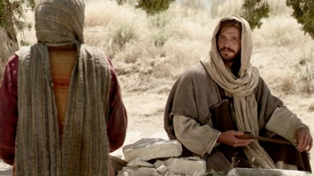
Well, he brought this up for a couple of reasons. First, Jesus wants her to know that he is who he says he is later on in verse 26. He’s not some stalker who’s been hiding behind a bush watching her life story, He’s the Messiah, the Son of God.

He’s all powerful and knows everything about her yet still accepts her. Just as he knows everything about me and still accepts and trusts me to share his love in my ministry work.
Second, Jesus knew that when He presents the promise of God to her, the promise that she can have this living water, the first thing she will think of is how all of her sins disqualify her.

You know that feeling of condemnation, when the devil comes a-roaming around, whispering the lie that we could never be accepted for who we are or what we’ve done. I for sure know that feeling - I can’t count the number of the time the devil stood in front of me and told me I was an evil person, that no one would listen to me. Imagine if Jesus had ignored this part of her story and not proceeded with grace.

The woman would’ve been crushed by the weight of shame and guilt, and maybe at this point, she still is because she immediately changes the subject. How many times have we done this?

She doesn’t know exactly who Jesus is yet, but she knows she can trust that what He’s saying is from God. And if it’s God who can answer her questions through Jesus, then why wouldn’t she ask Him anything she wanted to know?

I find it interesting that she brings up worship first. I’m sure she was confused about this God she didn’t know yet, this God that she maybe wanted to worship but didn’t know how to.

If Jerusalem was the only place to worship this God, the woman at the well knew she wouldn’t be able to have a part with Him since she was a Samaritan.

She was already despised enough in her home town, imagine going to a place where no one accepted you because of your nationality or skin color and trying to worship freely there. She couldn’t catch a break, it seemed. Except with Jesus, who did accept her and also us today!

Verses 21-26
Worship in Truth and Spirit

Though she did changed the subject, as many of us have. However Jesus doesn’t get mad at the woman at the well or condemn her, instead He answers her question with as much compassion as his first statements.

Because of Jesus, we don’t have to go to a specific place to worship. We don’t even have to be a Jew. This is epic news for the Samaritan woman, who otherwise would have no part of the redemptive story.

To worship in spirit means that we can worship God at anytime, anywhere, because we have the Holy Spirit with us, God’s very presence. Worship doesn’t have to be solely in a tabernacle, temple, or a church anymore.

The same Spirit that resided in the temple in the Holy of Holies, is the same Spirit that chooses to live in us. We have the Holy Spirit and because of that, we can experience the love of the Father without all of the rules of the Old Testament.

Another interesting thing to point out is how Jesus said “spirit and truth”. Why not spirit and peace? Or spirit and joy?

Going back to the feeling of shame or guilt the Samaritan woman was probably feeling, Jesus knew that it wasn’t cleared up just yet. For her to be able to worship in spirit and truth meant that she could be free to not hide anything from God.

She didn’t have to lie and cover up her sin and shame. She could be honest with God and still know that she is accepted and loved, if only she accepts the free gift of God’s grace, which Jesus is extending. The very same grace that Jesus has extended to you today.

Still, she’s hesitant to accept this, until Jesus actually says that He is in fact the Messiah. What is holding you back from accepting God’s grace?

I can feel the goosebumps that the Samaritan woman most likely experienced. Those words are not without extreme power, and they are undeniably special.

Throughout the gospels, it’s rare to find Jesus declaring exactly who He is. In fact, there were multiple times the disciples tried to drag it out of Him, and yet the Samaritan woman was worth telling this incredible truth.

Verses 27-30,
“Can This Be the Christ?”

The disciples did not understand what Jesus was doing. In later chapters, it takes many miracles before the disciples even declare Jesus as Lord, the Messiah. Perhaps you have had your own struggles in understanding the message of the Gospel. I know that was true in my life.
The Samaritan woman didn’t need long though, she knew that the change of love and grace and worship was bubbling up in her heart. She was experiencing the living water welling up inside of her to eternal life. What an incredible feeling. I remember that 1st time I fully accepted Jesus in my heart and experienced His living water flow throughout my soul.

You can have that too. Jesus is more than just a story on the page, Jesus is more than a faint Hebrew promise. It’s not unattainable for outsiders like us and the Samaritan woman. Jesus is here, and He is near to us. If you haven’t experienced His presence yet just ask Him to show you who He is and what He’s done for you. Just as I have asked and have been blessed with his presence in this ministry.

The woman at the well knew as you do now, that there is more. And she didn’t want to wait until heaven to find out how good Jesus is.

You don’t have to wait until heaven to know how good Jesus is. And you don’t have to wait to tell others about Him too. Let’s share this news to those around us. We do not need to clean ourselves up before asking Christ to be a part of our lives. He will meet us right where we are.

Many Samaritans Believe

Later on, in verses 39-42, the woman at the well runs back to Jesus with her town, showing them how amazing Jesus is and leading them into a relationship with Him.

Many Samaritans from that town believed in him because of the woman’s testimony, “He told me all that I ever did.” So when the Samaritans came to him, they asked him to stay with them, and he stayed there two days. And many more believed because of his word.

They said to the woman, “It is no longer because of what you said that we believe, for we have heard for ourselves, and we know that this is indeed the Savior of the world.”

It was the woman’s testimony that lead her town to Jesus, but ultimately it was Jesus’ love that changed them and convinced them that He was and is the Savior of the World.

If you believe this passage today, find the courage to share it with your Community, your friends, and family, so that everyone will be able to worship God in spirit and truth. I am so glad a Christian man shared the love God had for me, which I now share with you.

Forever Changed

When we meet Jesus and are transformed by His love, it’s not just something we keep to ourselves. We are forever changed. We want to tell everyone of this Good News.

Through His Holy Spirit, He will pour out the living water into our hearts, His goodness overflowing in us with His promises. His promise to the Jews was to bring salvation, and He extended that to the Samaritan woman and to us as well today.

Remember we don’t have to wait to enter the temple, we are the temple, we don’t have to wait until the next sacrifice, as Christ was our sacrifice and we don’t have to wait to enter into His presence. God will meet you right where you are. No matter how dark of a place you are in. Just call upon him and know how truly good He is. This is life with Jesus, this is truth and freedom.

Because of this, let’s rejoice in Jesus’ gift to us of His satisfying love, grace, and presence, worshiping in the spirit and in truth, right where you are.

We can run with the freedom and let others know of the amazing things He’s done for us. You may never know whose life you may save.

Your testimony is a powerful message of His love, grace and mercy in your life. That is meant to be shared to all around you.

May this message bring you hope and freedom always!

“THE FAST LANE”
Written by Michael Paul
I was living in the fast lane, and I was thinking it was a beautiful thing. Doing all the things that you love to do, and never thinking about what you may run into.

Seeing myself as being cool, while all the time becoming a fool. Trying to show others that you have some game, and never thinking it will end in pain.

Now I sit in a cell locked away, from the outside world which was a better place. Living in the fast lane brought me misery and it brought me pain. Now I call on “Jesus” name and now things will never be the same. I now know that the fast life is wrong, and all I desire is to get back home!

Some letters sent to us since the last newsletter.

Dated June 9th
Dennis
Allow me to convey my upmost respect. I pray this letter finds you in the best of health and high spirits.
Thank you for your letter and helping me find a great friend for a long time. I have shut myself out from God in the world. I got emotional hearing your story I too used to pray for God to take my life. I even attempted to take my own life and almost succeeded. Then I hit rock bottom and surrender to God. I was mad at the whole world my first 14 years. I’m serving life for crime I never committed, so you can imagine how I felt but my goal is to do Gods will and look forward to the kingdom of heaven. I believe everything happens for a reason if it’s God‘s will then it is so. May God bring down lots of blessings upon your life!
Respectfully Richard
Dated June 6th
Dear Mr. Dockham,
It is with utmost and sincere apologies that I write this to you and your ministry. Enclosed in my application for your pen—pal services were ill-wrought innuendos about who I am. I received your 2nd Edition newsletter in the mail yesterday and God touched my heart. For threaded into my motives in contacting your services were misguided and strong hopes of meeting a 'Misses Right". As stated in the application and reiterated in your newsletter are the words "this ministry is not a dating service". So...what was/am I looking for?
It must have taken extensive time and effort to construct your study of Ezekiel and I should be grateful that the church has dedicated members of the body who are willing to assist others incarcerated in their growth. As you probably have interacted with the panoply of prisoners from murderers, rapists, burglars, robbers to white-collar criminals, you are intimately familiar with penal life. You are also aware of the testosterone driven ambit of prison. Female staff become little more than prey and are completely objectified. This is not Gods design.
I am a man who has had a very severe traumatic brain injury and have suffered the consequences of my aberrant actions in its wake. But, that is not the man I am now albeit I still suffer the fleshly desires that led to catastrophe. Or at least I thought. I am very motivated, adept, skillful and always developing and honing my skillset for Christ. I also help and counsel others too.
I am cleaning up my motives. I really want someone, (male or: female), who is nonjudgmental-yes, a lot of so called Christians are some of the snobbiest and judgmental people-engaging and open-minded. Should a "right woman" come out of my experience with you great, if I meet another brother or sister in Christ and we become friends, that’s great too! You can never have too many friends. Part of what I do every morning is my neurotic routine which includes squaring tour and five digit numbers in my head in under five minutes followed by multiplying 3 x 3, 3 x 2 and 2 x 2 numbers in my head e.g., 789 x 567, 234 x 12 and 78 x 90 respectively. Something when considering the degree of brain damage I suffered, I should not be able to remotely do. PRAISE GOD! He has given me the impetus to be unstuck.
Now I aspire to help lead the way for prison reformation by utilizing my education and experiences juxtaposed with my talent for writing, speaking and devising/coordinating plans that God has given to me. Nobody is stuck the way that -they are. I have met a lot of men who have relegated themselves to this life, some on the life installment plan. I commiserate with the children and wives that they are neglecting in favor of this life.
One last note. Thank you for your patience and fervor in your ministry. Next time I write, I will include the lyrics for a Christian rock song I wrote years ago called “God bless.
Matthew J. Cullen
_______________________________

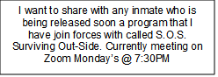
A heart felt “Thank You” to those who have made this issue possible with their donations. We have an awesome God who always seems to provide the means to publish and mail The Disciple Times.

May we continue to bless those who depend on our efforts in spreading the Gospel!

To those who have reached out to us on becoming a Pen Pal volunteer
“Thank you”! We are working on matching you up with an inmate.

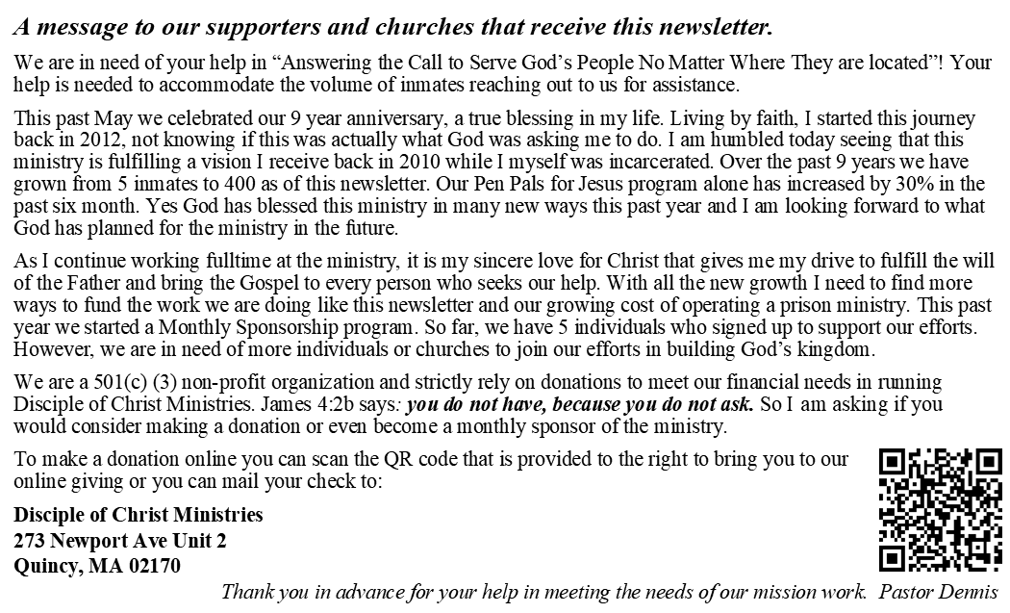

Answering the call to serve God’s People no matter where they are located!

273 Newport Ave Unit 2
Quincy, MA 02170-1727

