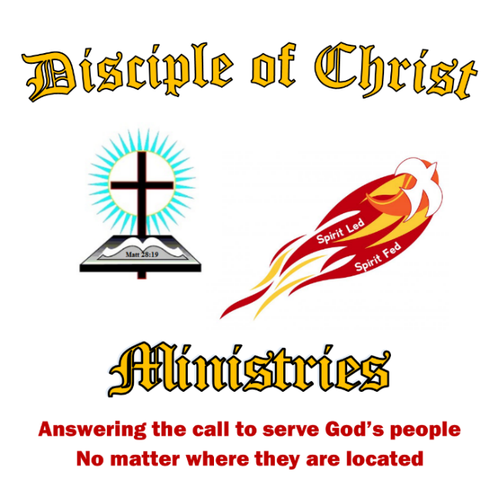

**Our mission is to spread the gospel of Jesus Christ where we live, work, and through prison ministry.**

***Life by the Spirit (Galatians 5: 13-26)***

You, my brothers and sisters, were called to be free. But do not use your freedom to indulge the flesh; rather, serve one another humbly in love. For the entire law is fulfilled in keeping this one command: “Love your neighbor as yourself.” If you bite and devour each other, watch out or you will be destroyed by each other. So I say, walk by the Spirit, and you will not gratify the desires of the flesh. For the flesh desires what is contrary to the Spirit and the Spirit what is contrary to the flesh. They are in conflict with each other, so that you are not to do whatever you want. But if you are led by the Spirit, you are not under the law. The acts of the flesh are obvious: sexual immorality, impurity and debauchery; idolatry and witchcraft; hatred, discord, jealousy, fits of rage, selfish ambition, dissensions, factions and envy; drunkenness, orgies, and the like. I warn you, as I did before, that those who live like this will not inherit the kingdom of God. But the fruit of the Spirit is love, joy, peace, forbearance, kindness, goodness, faithfulness, gentleness and self-control. Against such things, there is no law. Those who belong to Christ Jesus have crucified the flesh with its passions and desires. Since we live by the Spirit, let us keep in step with the Spirit. Let us not become conceited, provoking and envying each other.

Congue nihil imperdiet doming id quod mazim placerat facer minim veni am ut wisi enim ad minimeniam, quis erat nostr uexe

rci tation ullamcorper nostru exerci tation ullam corper et iusto odio dig nissim qui blandit praesent lupta. Tummer delenit

augue duis dolore te feugait nulla facilisi. Con erattis sectetuer adip iscing elit, sed erat diam nonummy nibh magna erat.

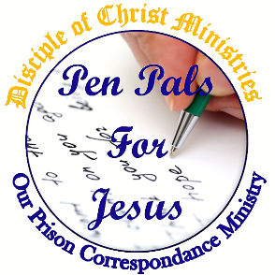

**Opening Doors**

**for the Lost and Forgotten Souls**

3/27/21

**Disciple of Christ Ministries**

273 Newport Ave Unit 2

Quincy, MA 02170

***A Spirit Led and Spirit Fed Ministry***

Reaching out to the lost and forgotten Souls.

Changing Lives.

Giving a message of Hope.

Teaching the Word of God.

Spreading the Gospel of Jesus

***How are we doing this?***

By developing a community of committed disciples of Jesus Christ, which will have an impact for Christ locally and around the world.

Through personal evangelism, the sharing of our own testimony of how God has worked in our life and the impact it has had on our personal relationships with Christ.

By building a strong “Christian Fellowship” and a team of missionaries, who will be able to write to those who are seeking the Lord Jesus in their life through our Pen Pals for Jesus Ministry! Thus, His sheep that have fallen into the ways of the flesh, will know Christ by giving them the same hope and faith that Christ has given to us so freely.

By developing a working outreach-mentoring program, which will be able to assist and help reintegrate those who are seeking a new and better life after incarceration.

Building resources with local and state agencies, to better assist in getting a person the much-needed services they so desperately need, like clothing, food, medical services, and housing.

Contact us at

Office: 617-237-9607

or on the web at [www.DiscipleofChristMinistries.org](http://www.DiscipleofChristMinistries.org)

Find us on Facebook @DiscipleofChristMinistries

Need Prayer text our Prayer line: 857-990-1910

***A message from our founder, Brother Doc***

*A New Look, and a Renewed Vision.*

**Are you new to our ministry?**

Whether you are just hearing about our ministry, or have been involved with the ministry over the past 8 years. I would like to welcome you to Disciple of Christ Ministries “Where the Lost are Found and not Forgotten”. Reaching outside the walls of the church building to answer the call to serve God’s people no matter where they are located, I consider myself blessed, to have the opportunity to serve God through this ministry since my release from behind the wall myself.

**What to Expect.**

***A Spirit Led and Spirit Fed Ministry***, spreading the Gospel, giving messages of hope, changing lives, and teaching the Word of God. Founded with the belief that one person can make a positive change in those who are out there lost and living in the flesh. Our work built upon the following five pillars of faith: 1) A duty to reach out to the lost and forgotten. 2) An obligation to lead by example. 3) An all-inclusive approach: We help everyone regardless of his or her religious beliefs. 4) That the path to salvation lies in our Lord Jesus, serving Him in everything we do. 5) That Christ will use our testimonies for His glory so others can see how God has taken our trials and tribulations and turned them into victories for Christ.

**The Vision.**

When God gave me the vision of this ministry, I had no idea how to start my journey after my release from the House of Correction in November 2011. Therefore, I walked out into the world with everything I had learned from studying The Word of God during my time of incarceration, preparing

the way for my newfound faith in Christ Jesus. Once out I turned my will over to God and asked the Holy Spirit to lead my way. Within a week, I was led to a Bible teaching church, where God continue to prepare me for ministry. Allowing the Holy Spirit to direct and guide me, I proclaimed my faith in the power of resurrection by a Full Immersion Baptism on March 25, 2012, confessing to my entire rebirth in Christ as written in scripture. I praise God every night for my salvation from my sins and for His daily guidance, He provides to me through prayer and meditation time.

By having faith in Christ, in May 2012 I formed the foundations of Disciple of Christ Ministries. As of July 31, 2020, this ministry is serving over 300 inmates in 37 States through our sub-ministry Pen Pals for Jesus. I continue to serve full time here at Disciple of Christ Ministries, living on faith that God will always make things work to the good of His Kingdom. I am a sinner saved by grace and am just a regular person whom Christ Jesus has given the strength and courage to lead a ministry. He considered me trustworthy, and appointed me to share what He has done in my life to reach the lost and forgotten.

**Ministry work.**

We are in need of your help in “Answering the call to server God’s people no matter where they are located.” Please find below different parts of our ministry that we could use help. All it takes is one person to make a difference in someone’s life. God has a way of putting people together for the good of His Kingdom. So I will ask you, are you the answer to someone’s prayer.

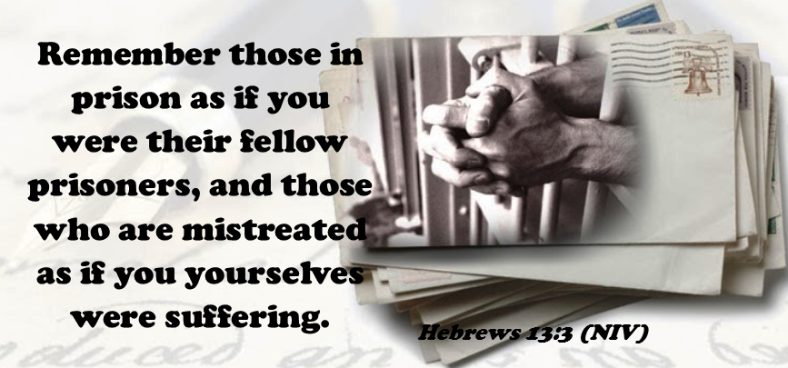

***Bible Studies >>>***

We would like to be able to offer a Bible Study Program to our inmates and sponsor local Bible Studies in our communities. We also need help preparing study material and locally help finding/hosting a place for a Bible Study.

***Outreach >>>***

There are still outreach opportunities that we are working on establishing, so we can fulfill our mission statement.

Building resources. We need to build resouses with local and state agencies to better assist in getting a person the much-needed services they so desperately need to get back on their feet, and to establish and maintaining a list of local places one can go to find clothing, food, shelter, and housing. Even a local church to attend.

Our Christian Mentoring Program. We need to reach out to help a fellow brother or sister in Christ reintegrate into the community and become a productive member in the community.

***Our Website >>>***

We have a website and two Facebook pages we maintain as our information and resources center for families and inmates. They need to be kept fresh and filled with new information as we continue to grow.

***Finical support>>>***

Sponsorship is a great way to help us keep our ministry reaching out to God’s children. By becoming a monthly sponsor with a $10, $25, or $50 a month donation. Or make a one time donation of any amount by mail or from our website. [www.DiscipleofChristMinistries.org](https://www.discipleofchristministries.org/make-a-donation/). And if you cannot make a cash donation we are always in need of Books of Stamps.

***Pen Pals for Jesus >>>***

Pen Pals for Jesus is reaching out to the

lonely men and women in prison. Most of the inmates contacting us have already accepted Jesus or they are seeking God. All of them are lonely, discouraged, feel rejected and in need of a caring friend.

We are in need of Christian brothers and sisters to write to inmates and shut-ins who are seeking Christian fellowship, and are looking to make changes in their lives and build a relationship with our Lord and Savior Jesus Christ. This is a very rewarding experience, as you become a Light of Christ to a fellow Christian, helping develop the same hope and faith we have experienced.

Also, you can help us keep our database up to date so our pen pals can be matched with our inmates sooner. Since we started Pen Pal for Jesus in 2012, we have ministered to over 1000 inmates in institutions across the United States.

***Our Newsletter >>>***

Our newsletter consists of eight pages filled with a Bible study, faith-building lessons, prisoner’s artwork, poems, and a message of hope from me. This past year we have published and mailed 325 Quarterly Newsletters 4 times. We have been typing, printing, and putting them together ourselves in-house. We are always looking to include new material and biblical teachings in our newsletters all help welcomed.

***Prayer Team >>>***

We are always looking for prayer warriors to assist with our Prayer Request we receive on our Prayer line 617-237-0019 and through our Prayer Request page on our website. www.discipleofchristministries.org

###### **Obedience to His Calling**