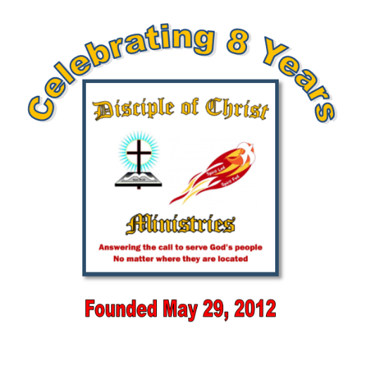
Summer Edition of
The Disciple Times
273 Newport Ave Unit 2, Quincy, MA 02170
Office: 617-237-9607 ~ Prayer Line: 617-237-0019
Web: www.DiscipleofChristMinistries.org & www.PenPalsforJesus.org
Serving God’s People for 8 years
We are praying for you and your family
“So do not fear, for I am with you; do not be dismayed, for I am your God.
I will strengthen you and help you; I will uphold you with my
righteous right hand.” ~ Isaiah 41:10

A message of unity and the wisdom to make those changes in our lives.
By Pastor Dennis
Before I get into this message, I would like to pray with you as if I was there with you.
Dear Heavenly Father, I come before your altar today, kneeling at the foot of the cross that Jesus was nailed to for my sins. His precious blood freed us from our sins. He died, was buried and raised from the dead to sit at the right hand of your throne. You assure me that if I believe in His death and Resurrection that I will live in eternity with you, that you have laid out my path and know me by name, created in your likeness, called a child of God.
Father God as we enter into another season of change across this land, we ask for your divine power to intercede on our behalf as we see fighting among our leaders that has spilled out onto the streets across America with protester and law enforcement clashing on the issues on hand.

We need you Father, in our lives and as a part of our community, to again open up the hearts of our leaders so that they will once again call upon your wisdom. Open their eyes so we can live where the color of a person’s skin does not determine their worth.
That we are created in your image and, in your eyes, you do not judge the color of skin only what is in our hearts.

I ask that you comfort and guide this individual in whose hands you placed this letter. I wish I could stand before them and lay my hands upon my brother or sister, extending your anointing Spirit to come over him or her so the Light of Christ would be shining upon any who have fallen into the darkness of earthly ways.

Father God I ask that you put them at ease knowing that you are with them, that this is only a season we must pass through. That you have told us in your Word if we have faith as small as a mustard seed, we could move mountains. Help them see your presence as they walk alongside of their peers regardless of the color of their skin. Let them be the church, sharing the peace and joy of knowing that they are loved by You - not lost or forgotten.

We pray this in your Son Jesus’ precious and Holy name. Amen.

I would like to begin this issue again with my sincere love for you through our Lord and Savior Jesus Christ.
Well, are you ready to start the second part of 2020? Time waits for no one - it seems the older I get the faster the time goes by me. What a first half we had so far, life as we knew it has changed in so many ways since 2020 started.
One thing I know for sure: I cannot predict what the next six months will bring us. However, I know God is in control and already has plans for us no matter what this world can and will throw at us.
Therefore, I will be still and know that God is with me. Have a blessed summer, be safe, and know that God is with you no matter who you are.
So let us get into our newsletter at hand and reflect on the gifts we have received from our Holy Father and the promises of our Lord and Savior Jesus.
We have all battled with the COVID- 19 pandemic that started in March and are still dealing with it today as we now enter into the 4th month of staying at home, wearing mask, gloves, and protective gear. Even many of you are still on lock down and still not able to have visitors. Some of you may have contracted the virus, no fault of your own. Please know that you are all in my prayers.
I started to put this newsletter together back in June with the topic, “It’s All about Jesus” about how my life changed during my time behind the wall by focusing on Jesus, how it played a part in who I am today and how this ministry started. The key I see now was that I allowed my faith in Christ to be my drive in serving God.
However, as I was putting it all together God changed my focus to the unrest in our country today. In discussions with some of my Christian peers, I was reminded of how racism was intertwined in my life. You see when I was a sixth grader (about 11 years old) in the year 1974 I saw the start of forced busing in the City of Boston. My family lived in a section of Dorchester called Savin Hill. At the time it was an all-Irish & Polish neighborhood. Yes, I lived in an all-white neighborhood.
Well when I moved from a local elementary school to Middle School, I was bused to the other side of Boston and things changed for me. Many of my friends came from families that were better off than mine were, so most of the kids I hung out with ended up going to Catholic or private school, while I went off to a school in a more culturally different area than my local school district.
What a time that was in Boston history as a Federal Judge ruled that the Boston School Committee had deliberately segregated the city’s schools, creating one system for blacks and another for whites — separate, unequal and unconstitutional.
The remedy to achieve racial balance and desegregate schools was busing. Some 18,000 black and white students were ordered to take buses to schools outside of their neighborhoods.
I had good and bad memories of my next 7 years in School. However, I must say for me there were more good than bad. I was able to create new friendships with kids that only had a different skin color than me. Yes, the first few months the bus carried me to school were scary as people threw rocks at the school bus, breaking the windows.
As I got older and went into High School, I took an entrance exam to get into a Technical School, still a Boston Public School with students from all nationalities. I remember a time that I was asked to be on a TV show about our school system and how racism affected the education in Boston. I attended this event with a good friend of mine in school. We went together as we had become good friends I being white and he being black. At that time, this just was not supposed to happen in the eyes of most adults in the city of Boston.
Well during the taping of the show, I remember a Boston City Council member from an all-white neighborhood. (I will refrain from giving his name), who was ranting and raving about black students coming into their white neighborhoods and just did not belong playing alongside their children.
Well back then, I was a very outspoken individual on student rights. I stood up against this city councilor on TV and said the only reason there was so much hatred in the city was that people like himself and the parents of students supported racism. Not the individual students themselves, as they were able to get along together without any hate.
It just sickens me that nothing has changed for over 40 years of my life. We are still dealing with the same old feeling that there always needs to be someone superior and someone lesser to make others feel suppressed.
So now that I gave you a little background of my experience of racism in my growing up. I want to share what God has put on my heart to help shed a little biblical response that I have put together for this edition of the newsletter. I looked into the Bible for what God’s Word says about it. After all “It’s All about Jesus” is it not?
What does the Bible say about racism?
Racism is about making quick judgments on the characteristics of a race to rate them as inferior or superior—demonstrating partiality or bias.
Racism is a problem we cannot ignore or run away from. It is an issue today, and it was an issue throughout history, including when the Bible was written.
An Ancient Story of Racism
Paul, one of the early church’s leaders, wrote about divisions caused by racism.
In first century AD, it was common to assign different values to different races and ethnicities. Foreigners, women, and children were generally regarded as property owned by the male heads of households and local rulers. Foreigners would often be employed in bonded labor (enslavement to pay off debts, as Jesus mentioned in (Matthew 18:21-35), making it difficult or impossible to live freely.
“The Parable of the Unforgiving Servant”
Then Peter came up and said to him, “Lord, how often will my brother sin against me, and I forgive him? As many as seven times?” Jesus said to him, “I do not say to you seven times, but seventy-seven times. “Therefore the kingdom of heaven may be compared to a king who wished to settle accounts with his servant. When he began to settle, one was brought to him who owed him ten thousand talents. And since he could not pay, his master ordered him to be sold, with his wife and children and all that he had, and payment to be made. So the servant fell on his knees, imploring him, ‘Have patience with me, and I will pay you everything.’ And out of pity for him, the master of that servant released him and forgave him the debt. But when that same servant went out, he found one of his fellow’ So his fellow servant fell down and pleaded with him, ‘Have patience with me, and I will pay you.’ He refused and went and put him in prison until he could pay the debt.
When his fellow servants saw what had taken place, they were greatly distressed, and they went and reported to their master all that had taken place. Then his master summoned him and said to him, ‘You wicked servant! I forgave you all that debt because you pleaded with me. And should not you have had mercy on your fellow servant, as I had mercy on you?’ And in anger, his master delivered him to the jailers until he could pay all his debt. So also my heavenly Father will do to every one of you, if you do not forgive your brother from your heart.”
At that time, one of the primary divisions in the church was between Jews and Gentiles. Some Jews who had joined the movement of Christianity were trying to force non-Jewish (Gentile) believers to perform the Jewish rituals. They argued that to be a good Christian, they had to do all the right Jewish religious activities, too.
Rather than telling Christians to ignore the discrimination against Gentiles, Paul addressed it head on: “There is no difference between Jew and Gentile—the same Lord is Lord of all and richly blesses all who call on him” (Romans 10:12). For there is no distinction between Jew and Greek; for the same Lord is Lord of all, bestowing his riches on all who call on him.
We see this echoed later when Philip, also a leader of the church, helps an Ethiopian eunuch understand part of the Bible and begin following Jesus (Acts 8:26-40). Now an angel of the Lord said to Philip, “Rise and go toward the south to the road that goes down from Jerusalem to Gaza.” This is a desert place. And he rose and went. And there was an Ethiopian, a eunuch, a court official of Candace, queen of the Ethiopians, who was in charge of all her treasure. He had come to Jerusalem to worship and was returning, seated in his chariot, and he was reading the prophet Isaiah. And the Spirit said to Philip, “Go over and join this chariot.” So Philip ran to him and heard him reading Isaiah the prophet and asked, “Do you understand what you are reading?” And he said, “How can I, unless someone guides me?” And he invited Philip to come up and sit with him. Now the passage of the Scripture that he was reading was this:
“Like a sheep he was led to the slaughter
and like a lamb before its shearer is silent,
so he opens not his mouth.
In his humiliation, justice was denied him.
Who can describe his generation?
For his life is taken away from the earth.”
And the eunuch said to Philip, “About whom, I ask you, does the prophet say this, about himself or about someone else?” Then Philip opened his mouth, and beginning with this Scripture he told him the good news about Jesus. And as they were going along the road they came to some water, and the eunuch said, “See, here is water! What prevents me from being baptized?” And he commanded the chariot to stop, and they both went down into the water, Philip and the eunuch, and he baptized him. And when they came up out of the water, the Spirit of the Lord carried Philip away, and the eunuch saw him no more, and went on his way rejoicing. But Philip found himself at Azotus, and as he passed through he preached the gospel to all the towns until he came to Caesarea.
You see other people do not determine your value; God does.
“God brings peace where there was once strife, and kindness where there was once animosity”.
So what does the Bible Says About Race and Favoritism
God cares how we treat each other because we are all created in His image (Genesis 1:27). So God created man in his own image, in the image of God he created him; male and female he created them. He makes no distinction between the inherent value of one race or ethnicity over another.
- God cares about people regardless of their ethnicity, nationality, and social status (Deuteronomy 10:17-19). For the Lord your God is God of gods and Lord of lords, the great, the mighty, and the awesome God, who is not partial and takes no bribe. He executes justice for the fatherless and the widow, and loves the sojourner, giving him food and clothing. Love the sojourner, therefore, for you were sojourners in the land of Egypt.
- "God does not show favoritism but accepts from every nation the one who fears him and does what is right" (Acts 10:34-35). So Peter opened his mouth and said: “Truly I understand that God shows no partiality, but in every nation anyone who fears him and does what is right is acceptable to him.
- "We were all baptized by one Spirit so as to form one body—whether Jews or Gentiles, slave or free—and we were all given the one Spirit to drink” (1 Corinthians 12:13) For in one Spirit we were all baptized into one body—Jews or Greeks, slaves or free and all were made to drink of one Spirit.
- "If you show favoritism, you sin and are convicted by the law as lawbreakers” (James 2:9). But if you show partiality, you are committing sin and are convicted by the law as transgressors.
- About the ages to come, we can see a heavenly picture: “a great multitude that no one could number, from every nation, from all tribes and peoples and languages, standing before the throne and before the Lamb” (Revelation 7:9-10). After this I looked, and behold, a great multitude that no one could number, from every nation, from all tribes and peoples and languages, standing before the throne and before the Lamb, clothed in white robes, with palm branches in their hands, and crying out with a loud voice, “Salvation belongs to our God who sits on the throne, and to the Lamb!”
- Jesus removes hostility and introduces harmony (Ephesians 2:14-18). For he himself is our peace, who has made us both one and has broken down in his flesh the dividing wall of hostility by abolishing the law of commandments expressed in ordinances, that he might create in himself one new man in place of the two, so making peace, and might reconcile us both to God in one body through the cross, thereby killing the hostility. And he came and preached peace to you who were far off and peace to those who were near. For through him we both have access in one Spirit to the Father.
We must all as Christians remember God is not about separation, but about inclusion and unity. Jesus made it possible for anyone to be included in the people and promises of God (Galatians 3:28). There is neither Jew nor Greek, there is neither slave nor free, there is no male and female, for you are all one in Christ Jesus.
Why Reconciliation Is Critical
The good news of the “Gospel” does not just mean that we are brought nearer to God. It also means we are brought nearer to the people we once considered so different from ourselves (Ephesians 2:13). Now in Christ Jesus you who once were far off have been brought near by the blood of Christ. God restores our relationships with people and groups we’ve mistreated. That’s called reconciliation: the removal of prejudice and the restoration of a relationship to healthy understanding and appreciation for each other.
God is a reconciling God. The Gospel is, at its core, a message of reconciliation.
God brings peace where there was once strife, and kindness where there was once animosity. He has done it with us and He can do it between us and our neighbors—whether black, white, Latino, or otherwise.
If we belong to Jesus, we are part of His movement to bring more reconciliation between people and God (2 Corinthians 5:18-20). All this is from God, who through Christ reconciled us to himself and gave us the ministry of reconciliation; that is, in Christ God was reconciling the world to himself, not counting their trespasses against them, and entrusting to us the message of reconciliation. Therefore, we are ambassadors for Christ, God making his appeal through us. We implore you on behalf of Christ, be reconciled to God. As His representatives, we have the opportunity to share how the life-changing message of the Gospel creates a healthy relationship with God and healthy relationships between people, no matter who they are.
So let us join together as Christian Brothers and Sisters and make it our job to make a difference in the world, as we learn to follow Jesus step by step. This includes reconciliation because the message of Jesus is that we all belong with God, together—no separation, no difference in status or worth. No matter if you are behind the wall or held captive in your own mind, we are all free in Christ Jesus.
I want to thank every one of you who has taken the time to read this newsletter. It is my hope that this message will give some comfort to those who are directly affected by the unrest in this world today. After all “It’s All about Jesus” is it not?
With all of God’s Love, Dennis

How Sad
By Anthony Passer,
Used with permission as long as not used for profit

Text of the day: 1 Cor.6:9-11
"Do you not know that the unrighteousness will not inherit the kingdom of God? Do not be deceived, neither fornicators, nor idolaters, nor homosexuals, nor sodomites, nor thieves, nor covetous, nor drunkards, nor revilers, nor extortioners will inherit the kingdom of God. And such were some of you. But you were washed, but you were sanctified, but you were justified in the name of the Lord Jesus and by the Spirit of our God.

How sad it is that our world has fallen so in love with violence and hate. That repentance leading to redemption have become so foreign in nature to our society that the very possibility of repentance leading to redemption having happened is considered impossible to comprehend. Now we are told that once a thief always a thief, once a killer always a killer, once a whatever always that whatever. Belief in the power of God to bring change for the good, His truth and evidence have no bearing on the world’s thought processes. Whatever the people in power are pushing seems right to the masses. We are warned in the last days will come false teachers deceiving and being deceived, so that even the very elect were they not careful could be fooled. No longer do even people who would have themselves and us believe they are godly, who swear they are "good" people trust in God's promise that through Jesus Christ, our incarnate God, all things are possible. That all things, even our mistakes, work for the ultimate good of those who love God, work to prepare us for His kingdom, and by His power we can overcome our sinful nature. How sad it is that the worldly society has decided it is far easier to just give up on people they have sworn that they love because they have fallen short and failed to be who they claimed to be. After all, once something always something! And isn't that convenient. Unless you happen to be the one that has failed. Unless you are the drug user, the adulterer, the liar, the thief, the whatever. It seems that the sins committed against us are always greater than the sins we have committed, funny how that works! At least until we have made that true commitment to the teachings of our Lord Jesus. I thank my Lord that He judges all sin to be sin, with no sin greater than another. For mankind confession, taking responsibility and repentance are not enough remedy for the sin to bring about forgiveness, if someone else is the sinner at least! Thank God, His ways are not our ways and His thoughts are above our thoughts. Otherwise, every one of us would be in deep trouble. But His grace is sufficient to bring about forgiveness and redemption for those who confess and repent. We have His promise that is true and God is not a man that He should lie! How sad it is that our world’s society has wandered so far from our creator God that if it's someone else who is the sinner it's easier to give up on them and treat them like last week’s garbage, just put it out on the curb to be hauled away and hopefully it will never be seen or heard from again, that is what would please man best, so long as they are not the one deemed last week’s garbage. How sad it is that our world has fallen so in love with hate. How Sad!
THE GREATEST
WINNER EVER

No recorded losses;
No defeats to mention.
He took every demon
in hell to school and expelled
them from contention.
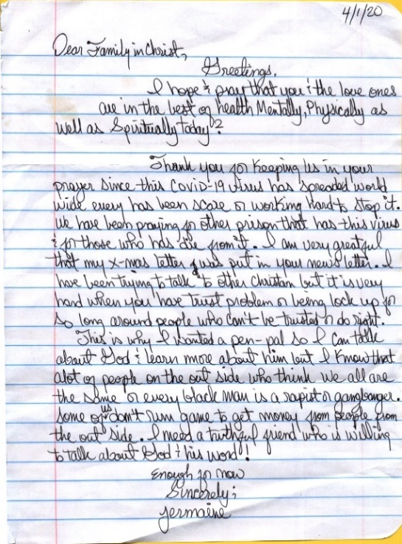
He ran a perfect race to save a cursed and wicked planet.
Baffling His archenemy,
Satan couldn't quite understand it.

He rose up to a brute challenge,
paid the greatest debt known to man. By His might and divine power, grace bled from His hands.
Freeing us from condemnation,
He did it from the cross.
Slain as our propitiation,
the Healer who never lost.

King Jesus, The Greatest
Winner Ever
1Corinthians 2:9 Exodus 3:14

By Aaron Frazier
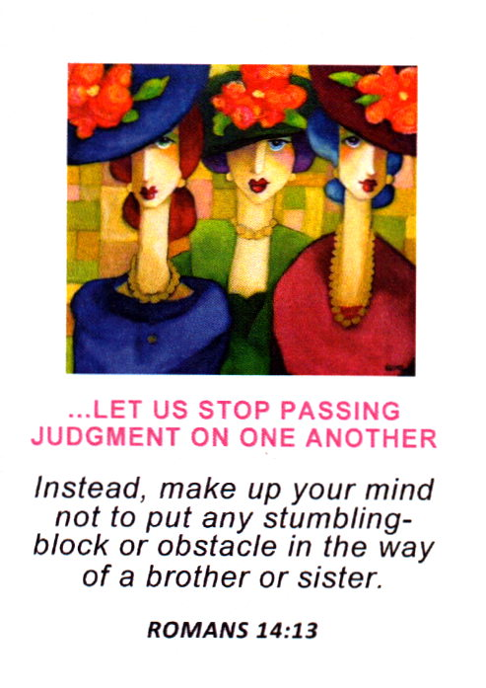

WORKING AND STRIVING TOWARD GLORY

Lord, Guide me to heaven
Turn the "high beams on"
Make the way so bright,
darkness will not even notice I am gone.

Anoint me to win souls,
Appoint me to help render the lost.
As I surrender, provide me a mercy so tender that I would triumph no matter the cost.

Keep me in blessed company
Give me the fight of faith to withstand. When I do battle, hold me in the saddle. Condition me for a position in the Promised Land.

In obedience, I shall take stride.
My life being a testament
to your glory. Push me on,
as I run toward home.
Hold me accountable to bring
along a blessed story.

Glory in the highest! Hallelujah!
AMEN! — Hebrews 12:1-2

God-Feared – AF
Letters from our inmates and supporters
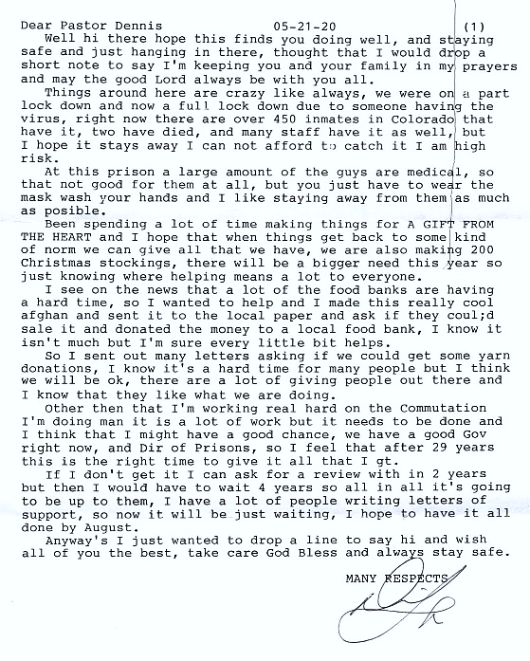

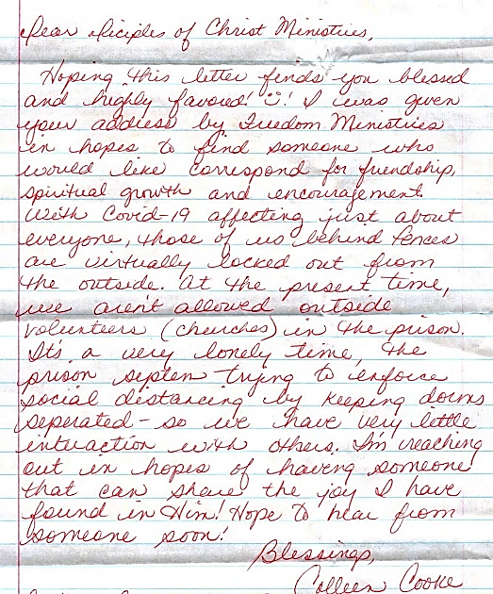
I want to thank all the inmates who have written to us over the past few months as we all deal with this pandemic. Since our last newsletter, we have received over 50 new requests for our Pen Pal for Jesus ministry. I want you to know that we are working hard at finding more volunteers to write back to you. Please know that you are all in my prayers as we adjust to the increase in requests for services.
I personally want to thank the following for joining us by sponsoring this ministry with a monthly donation. What a blessing! Matteo F., Sos G., and Roger R. In addition, I would like to thank Gordon B, Leslie & Neelia J for donating stamps for our mailings. A special Thank you to my old friend Gene L. for always being there to support the ministry. Without their help, we would not be able to operate.

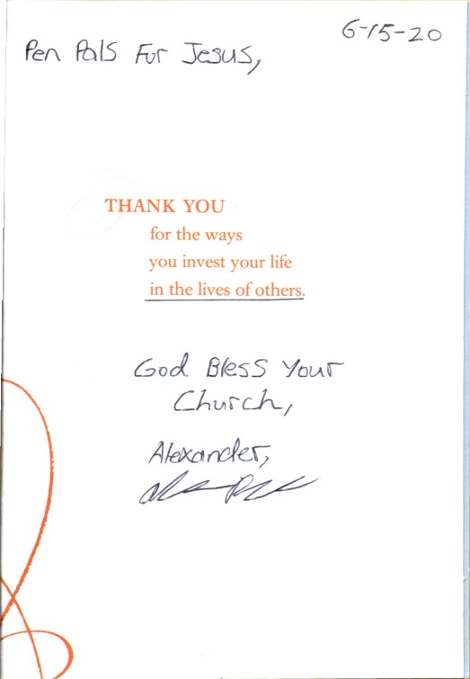
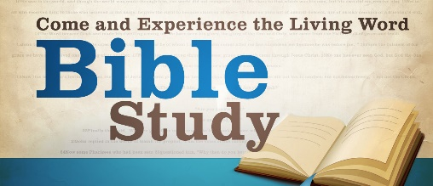
6 Ways the Bible Changed My Perspective on Ethnic Diversity
By J. DANIEL HAYS
Like many Christians, I grew up thinking the Bible was a story about people who looked a lot like me. This natural assumption was strengthened by my pictorial Bible (with Renaissance-era paintings of European-looking characters), Sunday school material, and Hollywood movies like The Ten Commandments (with Charlton Heston playing Moses). Perhaps you grew up with this same impression.
As I grew older and began to study the Bible more seriously, however, I realized this was a rather naïve and immature perspective. I discovered that the Bible’s storyline reflects quite a bit of fascinating ethnic diversity. And this diversity appears to be an important part of the storyline.
Here are six brief observations that changed my understanding of ethnic diversity in the Bible—and thus my perspective on ethnic diversity in the church.
1. All People Are Created in God’s Image
Interestingly, the Bible doesn’t begin with the creation of a special race of people. In Genesis 1 and 2, the first human is simply identified as ādām, which means “humankind.” Adam and Eve are not Hebrews or Egyptians or Canaanites. Their “race” or “ethnicity” is not identified. And they become the mother and father of all peoples and all ethnicities. The beginning of the biblical story, then, is not about white people or black people or brown people. It is a story about all people.
Further, Genesis 1:26–27 tells us that God created them (“humankind”) in his image. This truth has profound implications, for it insists that people of all races and ethnicities are created in the image of God. And since all bear his image, all deserve to be treated with special dignity and respect.
2. Israel Was Ethnically Diverse
The composition of ancient Israel reflected the multi-ethnic makeup of the biblical world. The Old Testament world was multi-ethnic, and the ethnicities of the biblical characters reflected that.
While many of the characters in the Bible are Semitic (and thus looked like modern-day Israelis or Arabs), the story frequently includes individuals and groups from a wide spectrum of ethnicities. Abraham, for example, was from Mesopotamia, and ethnically he was probably an Aramean/Amorite. He and his family migrated to Canaan, where two of his descendants (Judah and Simeon) married Canaanites, while their brother Joseph married an Egyptian.
Later, when God delivered Abraham’s descendants from Egypt, a “mixed multitude” went with them as they left Egypt (Ex. 12:38), implying that people from other ethnic groups accompanied them and thus became part of Israel. Indeed, throughout the Old Testament there is a frequent influx of persons from other ethnicities into the people of God, including the Cushite wife of Moses (Num. 12), Rahab the Canaanite (Josh. 2–6), Ruth the Moabite (Ruth 1–4), Ebedmelech the Cushite (Jer. 38–39), and so on.
3. Black Africans Were Involved in God’s Plan of Redemption
One distinctive ethnic group that shows up repeatedly in Scripture is the Cushites. The terms “Cush” or “Cushite” occur in the Hebrew Bible more than 50 times. In English Bibles it’s often translated as “Cush,” but sometimes as “Nubia” or “Ethiopia.” Cush was a powerful Black African kingdom located along the Nile River just to the south of Egypt.
Black Cushites were active players in the geopolitics and economics of the ancient Near East throughout most of the Old Testament period. The Cushites even controlled Egypt for a short while (during the time of Isaiah) and allied themselves with Jerusalem against the Assyrians. Later, the Black African Ebedmelech played a crucial role in Judah’s theological history, saving the prophet Jeremiah and symbolizing the inclusion of future Gentiles who will come to God by faith (Jer. 38–39).
The first non-Jewish believer in the New Testament was a Black African.
In the New Testament, this region is usually referred to as “Ethiopia,” even though it differs from modern Ethiopia. The “Ethiopian Eunuch” in Acts 8 was a Black African from this region along the Nile River, south of Egypt. He was the first non-Jewish believer in the New Testament and, like Ebedmelech in the book of Jeremiah, he seems to symbolize or foreshadow the approaching Gentile inclusion in the rest of Acts.
4. Moses Married a Cushite (Black African) Woman
In Numbers 12, Moses, while walking faithfully with the Lord and in the power of the Lord, marries a woman from Cush. There is little doubt that this woman was a Black African. And in the story, God seems to give his total approval to this marriage.
This is a strong statement on the biblical acceptability of interracial marriage. In other Old Testament texts there are prohibitions against marrying Canaanites and other inhabitants of Canaan, but these prohibitions weren’t due to ethnic differences but theological differences, since the Canaanites worshiped pagan gods. The prohibition was against marrying outside of the faith.
5. People from All Ethnic Groups Are United in Christ
In the New Testament, Paul demands active unity in the church, a unity that explicitly joins together differing ethnic groups because of their common identity in Christ. Paul proclaims that, in Christ, believers form a brand-new humanity. The old barrier of hostility and division between ethnic groups has been demolished by the cross; and now, all peoples are to be one in Christ (Rom. 4; Gal. 3–4; Col. 3; Eph. 2).
Christians of other races aren’t just equal to us; they are joined to us.
Paul insists that the primary identity of Christians is to be based on their union with Christ—not on traditional sociological, geographical, and ethnic connections. Again, the implications are profound. Christians of other races aren’t just equal to us; they are joined to us. As Christians, we’re all part of the same body, united by the presence of the same Holy Spirit who indwells us all. We’re not just friends or fellow worshipers in the same religion, but brothers and sisters in the same family.
6. The Book of Revelation Portrays a Multi-Ethnic Congregation
John gives us a glimpse of the people of God at the consummation of history, describing them as people from every tribe and language and people and nation (Rev. 5:9; 7:9; 10:11; 11:9; 13:7; 14:6; 17:15). This fourfold formula of tribe, language, people, and nation stresses the ethnic diversity of the people of God who will worship around the throne. It’s a picture of the climactic kingdom of Christ, and, as such, provides a model for us to strive toward. John clearly sees the kingdom of Christ as a multi-ethnic congregation.
These six brief observations are far from exhaustive, but hopefully they will help you get started on rereading and rethinking what the Scriptures really say about ethnic diversity.

Author’s note: For further discussion of these themes, see my book From Every People and Nation: A Biblical Theology of Race, in the New Studies in Biblical Theology (NSBT) series edited by D. A. Carson.
J. Daniel Hays (ThM, Dallas Theological Seminary; PhD, Southwestern Baptist Theological Seminary) is dean of the Pruet School of Christian Studies and professor of Old Testament at Ouachita Baptist University.
In partnership with the Greater Boston Chapter of Full Gospel Business Men’s Fellowship in America, we have started a men’s support group called S.O.S. (Staying out Side) for prisoners who have been recently released or have done time before. For more info, please contact Dennis

273 Newport Ave Unit 2
Quincy, MA 02170-1727

Jesus replied, ‘Truly I tell you, whatever you did not do for one of the least of these, you did not do for me.
Matt 25:45 (NIV)

How we all ought to live!
Scripture:
Be an example to all believers in what you say, in the way you live, in your love, your faith, and your purity. Until I get there, focus on reading the Scriptures to the church, encouraging the believers, and teaching them. – 1 Timothy 4:12-13
Observation:
Timothy was a young preacher and teacher of the Word of God and studied under the tutelage of Paul and was like a spiritual son to the apostle. He must have endured a lot of slander because of his young age, for Paul encouraged him to continue in the faith and do the work given to him by God through the elders laying on of hands and prophesying over him. Paul told Timothy to set an example before other believers in all he said, did, and thought through purity. What a message!
Application:
Applying what we hear from God’s Spirit speaking to us. His words couldn’t be any louder than they are today! “Be an example to ALL believers! In word, in deed, in love, in faith, in purity, LIVE A GODLY LIFE!” He even goes on to tell me to focus on reading the Word of God to the church (the entire church worldwide not just the local assembly), to encourage believers, and to teach them the TRUTH of Jesus! We all could stand to learn this lesson and put it into practice, for every person who is a true disciple of Jesus has been commanded to go and make disciples of all nations, baptizing them in the name of the Father, Son, and Spirit, and to teach them all Jesus taught the apostles.
Prayer:
Father, thank you for loving me and being so gracious and merciful. You are to be revered, honored, glorified, and lifted up! You are supreme and with majesty that shines brighter than the sun! I love you for who you are not what you do for me. Help me to live out the command you gave Timothy through Paul. In all I think, say, and do, may it bring you glory and honor! May it be the truth and truth alone! Your will be done, not mine, In Jesus’ name, Amen.

