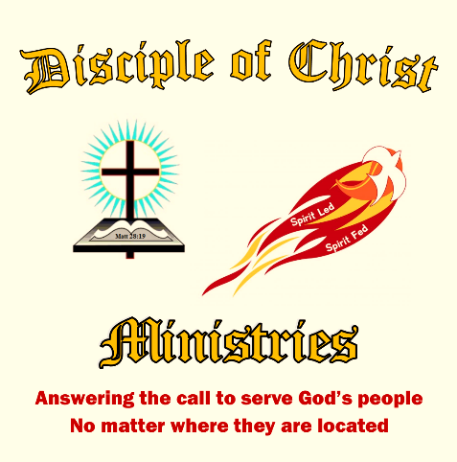
Special Edition of
The Disciple Times
273 Newport Ave Unit 2, Quincy, MA 02170
Office: 617-237-9607 ~ Prayer Line: 617-237-0019
Web: www.DiscipleofChristMinistries.org & www.PenPalsforJesus.org
Serving God’s People for over 7 years
“So do not fear, for I am with you; do not be dismayed, for I am your God.
I will strengthen you and help you; I will uphold you with my
righteous right hand.” ~ Isaiah 41:10

A message of hope and encouragement during the virus crisis.
By Pastor Dennis
Before I get into this message. I would like to pray with you as if I was there with you.
Dear Heavenly Father I come before your altar today, kneeling at the foot of the cross that Jesus was nailed to for my sins. His precious blood freed us from our sins. Died, buried and raised from the dead to sit at the right hand of your throne. You assure me that if I believe in His death and Resurrection that I will live in eternity with you. That you have laid out my path and know me by name, created in Your likeness, called a child of God.
Father God as we enter into the unknown effects of this dreadful COVID-19 virus I ask that you comfort and guide this individual in whose hands you placed this letter. I wish I could stand before them and lay my hands upon my brother or sister, extending your anointing Spirit to come over him or her so the Light of Christ would be like a beacon to those around them who have fallen into the darkness of earthly ways.
Father God I ask that you put them at ease knowing that you are with them, that this is only a season we must pass through. That you have told us in your Word if we have faith as small as a mustard seed, we could move mountains. Help them see your presence as they walk alongside of their peers and be the church, sharing the peace and joy of knowing that they are loved by You - not lost or forgotten.
We pray this in your Son Jesus’ precious and Holy name. Amen.
I would like to begin this issue with my sincere love for you through our Lord and Savior Jesus Christ. As the world around us spins into fear and uncertainty with the coronavirus affecting every part of our earthly lives, I have spent hours in prayer and meditation this past week. Allowing the Holy Spirit to guide me as I sought God’s wisdom in writing a message of encouragement and hope, bringing peace and comfort through the Word of God to all those around me. God put it upon my heart to put this letter together as many of you are in lockdown or even maintaining the “Social Distancing” keeping you secluded from contact with your earthly family. I hope that this special edition brings you peace, love, and faith in knowing we have a powerful and forgiving Father. May the presence of God walk alongside you now and forevermore!
In the midst of this crisis, we must not only pray. Though we must most fervently pray, we must also work. There are many things to be done and it is going to be up to us to do them. The church was never about a building it is about the people who make up the church. We may not have a building or a meeting place to worship right now or celebrate His Holiness as a group of Christians in one place. However, we can be joined as one in Christ and be the church. Bring the Light of Christ into the darkness that seems to be taking over the life of people around you.
You ask how do you have peace in the middle of a pandemic? How do you have faith over fear and an unknown future? Here is how you trust Jesus with your life. When I finally gave my life over to God and accepted Jesus as my Lord and Savior my life was in turmoil. I pleaded with God to take my life, as I no longer wanted to live. Well I heard God speaking to me - these are the words I heard: ok so you want me to take your life. Then get up and follow me. Since that very day, I have walked in faith into many difficult times before and after my own release from Jail in November 2011.
One of the most puzzling verses when I first became a Christian was, ‘My grace is sufficient for you, because My strength is made perfect in your weakness.’ That was so completely upside down for me. Weakness? Now I embrace that with the fullness of everything around me when I realize that my strength is inadequate, whether it the coronavirus or some family crisis, God's strength is always sufficient. Over the years, I can look back and see God’s hand throughout my 57 years on earth.
During this time with the coronavirus, fear is gripping the hearts of people around the world. There is a mountain of anxiety and alarm, and it is still building. It is as real as the virus itself—but it is treatable. There are people in need that we can reach out to help. Just as a firefighter runs to the fire, the church needs to respond to crises around us. We who are the church need to stand up and be the hands and feet of the Lord Jesus Christ.
We should all hope for the best-case scenario, even as we prepare for the worst case. Prudence and precaution is not a sign of panic or fearfulness, but as the Bible commands us, of bearing one another’s burdens (Gal. 6:2) and thinking more highly of others than ourselves (Phil. 2:3). When we get through this dreadful COVID-19, many thousands of people will come back to church longing for personal reality with the living God. Let’s get ready. Let’s release our grip on the defunct patterns of the past and reach out by faith for what only God can do.
You must always remember that
this world can often feel like a dark place. Sometimes it’s hard to see light and hope in the midst of all the suffering and pain we see around us. Constant media headlines reveal the deep struggle, the pain, and brokenness so many have known.

God's promises are true and He is faithful to bring them all to pass. Every single one. Jesus gives us eternal hope, rooted in Him, the promise of heaven, and the reminder that He will come again.

Please know that your prayers are being answered, you do not stand alone, you have Christ in you.

In Christ Love
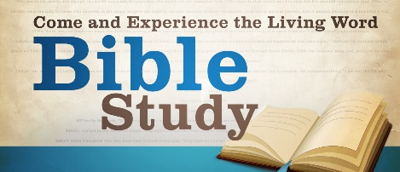
Dennis Dockham
How Do I Walk by Faith in the Middle of Widespread Fear?
By Anne Peterson

If you’re really quiet you can almost hear it: the heartbeats of those around you. People are scared. We try to distract ourselves so we get more information, thinking it will help diminish fears. But instead, fears grow.

So what do we do when we are surrounded by fear?
Here are 6 ways to demonstrate faith in the midst of widespread fear:
- Feed on God’s Truth
Like many of you, as news of the coronavirus spreads, I’m tempted to be afraid. And sometimes I’ve given into that fear. Through this, I’ve found that what I put into my mind determined how I would feel. In Romans 10:17, Paul tells us faith comes by hearing the Word of God. And we’ve all experienced holding onto faith. We’ve all at times leaned into knowing that God will work, when things seemed impossible (Luke 18:27). What we put into our minds floats around in there. And while we get swept up in the day’s news, convincing ourselves more knowledge will help us worry less, it doesn’t always work like that. When you finally rest your head on your pillow at night, and close your eyes, the images parading in front of you are often the images you saw that day. The temptation is great to give into fear. Especially in a crisis where they are scared. But, if faith comes by hearing the Word of God, we’ll never have faith when we feed only on what the world says instead.
- Meditate on God’s Word
Think back on a circumstance God got you through, and search your mind for a verse that kept you afloat. Below are a few of mine, if your memory isn’t serving you very well right now. And by the way, don’t be surprised by that ‘fogginess.’ Going through stressful times consumes energy, which affects mental capacity as well. Here are some verses worth memorizing:
Deuteronomy 31:6 - God says to be strong and courageous. To not be afraid or terrified. Why? Because God goes with you, he will never leave nor forsake you.
Isaiah 26:3 - God will keep you in peace when your mind is steadfast because you trust in Him.
Isaiah 41:10 - God reminds you that you don’t have to be afraid for God is with you. He is our God and he will uphold each of us with His hand.

When Jesus himself was being tempted in the wilderness (Matthew 4:1-11), the enemy kept throwing scenarios at him. But Jesus answered Satan the same way over and over: “It is written.”

We are so fortunate to have the Bible so we can read God’s truth and find real answers to life’s problems. Let those verses seep into your fearful mind and keep you steady.
- Hold God’s Hand
When I’ve gone through difficult times in my life, I’ve made it, because I learned to hold onto my Heavenly Father’s hand. These two poems I’ve written address that simple trust.
His Hand
I do not understand my life, it’s difficult for me
Some questions have no answers, at least that I can see.
And yet, with every year I’ve grown, there is a truth that God makes known,
I do not have to understand, but simply hold my Father’s hand.

If you’ve ever seen a child take their first steps, they are kind of wobbly. The only way they can navigate is holding onto someone’s hand. As adults, we can still do that today.

My Father’s Hand
The world may never understand,
why I still hold my Father’s hand.
It doesn’t matter, I don’t care;
for when I call, my Father’s there.

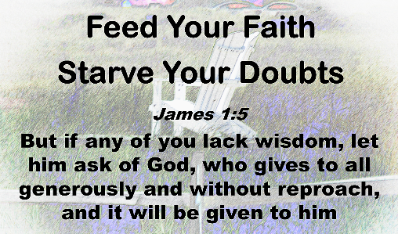
When you are holding onto someone’s hand, you don’t have to worry about falling. They will catch you because they are concerned about you. Their steps are sure and they’ve got experience on uneven ground.
- Sing or Listen to Uplifting Music
Perhaps a song that once helped you will pop into your head. One you sang, or one you heard. Just listening to that song transported you to a place of peace. Your circumstances didn’t change, but your thoughts did. And when our thoughts change, it changes our behavior.
When I go through difficult times, I listen to this song by my son, Nathan Peterson.
When he and his wife had a baby with Trisomy 18, a genetic disorder, their whole life was turned upside down. And when she slipped into heaven, they tried finding rest. You can hear that struggle as you listen to his words. May you find peace and rest as well.

- Watch Where You Look
As you focus on who God is, you get a different perspective. As your eyes are on Jesus, like Peter’s were in John 14:22-33, you can also walk by faith. But when you look at the wind and waves around you, like Peter, you will slip down. The good news is, God will reach down immediately and pull you up again. He’s that close to you. Psalm 46:1 says that God is your refuge and strength. A very present help in trouble. He’s there. He’s always there. The world is scared right now. They read and hear what’s happening not only here, but in other countries and fear grabs onto us. But God is still here. And he is sovereign. While some of the news we hear surprises us, nothing surprises our God.
Paul said in 2Corinthians 12:9-11, when he is weak, then he is strong. He talked about his hardships, persecutions, difficulties. The only reason Paul was strong was that God became his strength. And God offers that to you and me as well (Matthew 11:28). God offers rest.
Look around. There are scared people everywhere. Some of them have nothing to hold. Some know nothing of God’s Word and God’s presence. Christians, living by faith, can be the ones to share. For when we all put truth into our minds, God gives a peace that passes understanding (Philippians 4:7). You may not feel like a rock some days, but you can lead others to the one who is our rock (Psalm 18:31 and 2 Samuel 22:2)

- Pray without Ceasing
God says in 1 Thessalonians 5:17 to pray without ceasing. As I journal, I pray for people with cancer, those struggling in their relationships, those with financial needs. I pray because God is the answer to all of our problems:
Proverbs 3:5-6
Trust in the Lord with all your heart and lean not on your own understanding; in all your ways submit to him, and he will make your paths straight.
Isaiah 26:3 NLT
You will keep in perfect peace all who trust in you, all whose thoughts are fixed on you!
John 16:33
“I have told you these things, so that in me you may have peace. In this world you will have trouble. But take heart! I have overcome the world.”
Hebrews 11:1
Now faith is confidence in what we hope for and assurance about what we do not see.
James 1:6
But when you ask, you must believe and not doubt, because the one who doubts is like a wave of the sea, blown and tossed by the wind
As Paul said
Finally, brothers and sisters, whatever is true, whatever is noble, whatever is right, whatever is pure, whatever is lovely, whatever is admirable if anything is excellent or praiseworthy think about such things. (Philippians 4:8)
God is Jehovah Jireh, the one who meets our needs.
God is Jehovah Rapha,the God who heals.
God is Jehovah Shammah, the Lord is there.

Hebrews 4:16 invites you to come before your Holy God and to place your requests before him. Some people know nothing about that. If Christians answer his call to fill our minds with truth about God, if we take
his hand, and keep our eyes on him, people around us will notice something different. And then we may have the opportunity to give an answer of the hope that lies within us (1Peter 3:15). When people are scared, they are looking for answers to dispel their fears. Those of us who know the Lord personally and are walking in faith can offer answers others need. People need a rock to hold onto, and you and I can lead them to that rock.

A Prayer to Walk in Faith Not Fear
Let us pray, as we close this letter

Father, God, you are Almighty. No matter how scary things may look around us, you are bigger still. Lord, none of what we go through day to day surprises you. You are the Alpha and the Omega. The beginning and the end. You are our rock and our deliverer. And yet, you are the gentle God who knows when even a sparrow falls, as we learn in Matthew 10:29. Loving Father, thank you that you never step back, but instead, you stay right near us. And you’re close enough to hear our hearts beat, the very hearts you made. Father, give us wisdom and grace for each day. And give us the words to say to those who need to hear them. We pray this in your Son Jesus’ precious and Holy name. Amen.

"GOD IS BIGGER THAN YOUR CHALLENGES"

We are in a spiritual warfare. But the church has the answer. We, as believers, live in the world, but we are not of the world. (John 17:16). Ephesians 6:12; "For our struggle is not against flesh and blood, but against the rulers, against the authorities, against the powers of this dark world and against the spiritual forces of evil in the heavenly realms." We must step up to the plate in our confessions and testimonies; we must also understand that the church is not a building, but the people are the church. There are seven things to remember about God instead of fearing anything in this world. 1) Don't fear what the world is fearing. 2) Perfect love cast out fear. 1John 4:18; "There is no fear in love. But perfect love drives out fear, because fear has to do with punishment. The one who fears is not made perfect in love." Remember the love God has for you. He is bigger than the coronavirus or any disease or adversity. 3) Trust in His faithfulness. 2 Thessalonians 3:3; “But the Lord is faithful, and he will strengthen you and protect you from the evil one”. Keep trusting in the faithfulness of God. 4) Walk in God's way. When you walk in God's way, you have divine protection. 5) Keep your focus on Jesus. Keep your mind more on Jesus rather than social media and television. Make sure God is your first priority. 6) You reign as a believer. Romans 5:17; "For if by one man's offence death reigned by one; much more they which receive abundance of grace and of the gift of righteousness shall reign in life by one, Jesus Christ. You are the righteousness of God. 7) Speak faith. You must speak your faith to activate it. Remember in the book of Genesis God spoke everything into existence. 1Kings 17:1; “Now Elijah the Tishbite, from Tishbe in Gilead, said to Ahab, “As the LORD, the God of Israel, lives, whom I serve, there will be neither dew nor rain in the next few years except at my word." When you speak as a believer, you speak God's Word. God flows through you. His light shines through you when you preach the Gospel to others. You have the power to heal the sick and cast out devils. (Matthew 10:1,8). Go out and be the Church!

Hallelujah, Hallelujah, we praise you Lord Jesus!

273 Newport Ave Unit 2
Quincy, MA 02170-1727
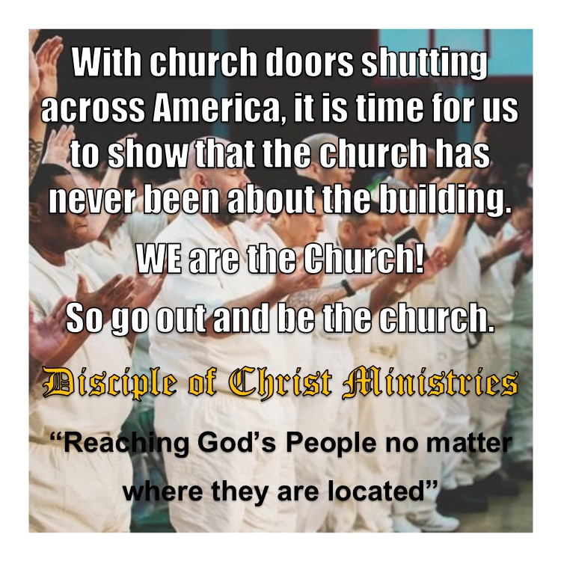

Jesus replied, ‘Truly I tell you, whatever you did not do for one of the least of these, you did not do for me.
Matt 25:45 (NIV)

