Febuary 2020
The Disciple Times
273 Newport Ave Unit 2, Quincy, MA 02170
Office: 617-237-9607 ~ Prayer Line: 617-237-0019
Web: www.DiscipleofChristMinistries.org & www.PenPalsforJesus.org
Serving God’s People for over 7 years
Continue to remember those in prison as if you were together with them in prison, and those who are mistreated as if you yourselves were suffering. (Hebrews 13:3 NIV)

From the Desk of
Brother Doc

Dear Brothers and Sisters in Christ,

Let me first apologize for such a long delay on this issue. I hope that this newsletter finds you in high spirits and in a blessed way.

As I prepared this newsletter, the Holy Spirit led me to bring up the topic of stepping out of your comfort zone. What does it mean to step out of your comfort zone? It could be to try new ways of living and thinking that might be unfamiliar and scary at first. Or breaking a routine habit that feels comfortable and safe, but isn’t really helping you live God’s abundant life.

I myself can remember how uncomfortable it was being a new Christian while I was serving time, the many challenges I faced from unbelievers and the feeling of what I can only call the dark evil spirits of the devil’s playground. Now I am not saying that every institution is filled with evilness but there is a lot of darkness within the walls. Stepping out of your comfort zone while serving time is a daily challenge, in which God will stand with you and guide you, if you are willing to take the leap of faith and follow that burning desire within your heart that God has placed there.

My life did not get easier when I was released. It was very challenging and uncomfortable, not knowing where I would be able to live, but I committed my life to Christ before I even left the institution I served my time in. I offered myself up to God, pleading with Him to bring me to the places I need to go, to become a humble servant. Well, my first stop was going to a shelter, as I had no other place to lay my head - my first uncomfortable encounter in my newfound life with God leading the way. I see today that by my obedience to God my stay at the shelter was only for a short time. During those days, I was able to hear God speak to me giving me better insight of His plans for me, leading me to my next step in this journey.

However, it was during that time I saw an opportunity to step out of my comfort zone and continue the work that God had placed upon my heart while learning the Word of God before my release. You see God did not let me down; He walked alongside of me and took me by the hand through this most important part of my new journey.
As I have mentioned before, God spoke to me through my 1st home church, which the Holy Spirit led me to on my 2nd week out as I was seeking housing. With the confidence in knowing that God would be my guide I boldly introduced myself to the pastor and set up a meeting. I met with the pastor the following week and talked about my incarceration and that I was seeking a Bible teaching church to help me with my continued growth as a new Christian walking with Christ. Also I shared that I had been praying for over a year for a church that would accept me not for who I was, but who I became, a sinner saved by grace that had become a new creation in Christ Jesus. Since then God called me to my current home church.

I guess what I’m trying to say is that we have to sometimes feel uncomfortable in situations where we have no control. As we go through these uncomfortable times we gain knowledge. God uses our circumstances for His glory, so that others can see the hand of God working in our lives today. As I look back over the past eight years, I see that my life has changed dramatically from being a self-centered, egotistic, power-hungry
individual, to a God-fearing man, humbly serving God.

Today, I stand here in an uncomfortable environment willingly serving a loving God who loved me so much He sent his only Begotten Son to die for my sins. Over the past few months I’ve been stepping out of my comfort zone, being obedient to whatever God leads me to do in building this God given ministry. This includes reaching out to many new churches and sharing the vision of this ministry so we can fully glorify God in all things we do. As the next few months come I faithfully seek God’s guidance and wisdom in the building of this ministry to the full potential of the plans that God has for all of us as we serve now, and the lost and forgotten souls God will send in the future.

So as I close this letter, my question to you is: Are you willing to step out of your comfort zone to serve a loving forgiving God? This question is not just for those who sit behind barbed wire and steel bars; it is also for those who feel imprisoned in their own lives. We have many Christian brothers and sisters who proclaim Jesus Christ as their Lord and Savior, who not only seek but pray to God for someone that they can share their walk with Christ with. You will never know if you are that one person that God has in His plan to answer the call of his people, who are crying out to Him in prayer. You can make a difference in one person’s life. I am one of those who cried out to God in prayer and God sent many to guide me in my journey behind the wall.

Your faithful servant,
Dennis Dockham

Our Bible Study
Question: "In what ways should Christians be prepared to step outside their comfort zone?"
Answer: Christ asks His followers to die to themselves, to take up their crosses and follow after Him (Matthew 16:24). Taking up a cross and dying to self are not “comfortable” actions, and Christians should always be willing to step outside their comfort zone into any situation God may place them.
In a certain sense, the very act of becoming a Christian can put one in unfamiliar territory. Christ calls His followers to stop seeking earthly riches (Matthew 6:19), to not worry about the future (Luke 12:22), and to live sacrificially to seek the good of others (Matthew 22:39), all of which run contrary to the values of the world. These teachings call Christians to live a lifestyle radically different from what they were accustomed to before their conversion.
Placing one’s faith in Jesus Christ for salvation requires a big step outside our comfort zone. We are naturally bent away from God in our very nature (Romans 3:10–18), and our natural inclination is to rely on ourselves in some way to be saved: we think we can just be good people or that our wealth proves God’s favor or that by performing certain actions we can “cancel out” our sins. But this is insufficient. To surrender ourselves completely to God, to place our faith exclusively in Jesus Christ to save us, requires us to deny our instinct to save ourselves (Ephesians 2:8). In this sense, all Christians step outside their comfort zones simply by becoming Christians.
But what about our day-to-day lives? Having given ourselves over to Christ, how should we be stepping outside our comfort zones? It may mean associating with people we previously saw as uncomfortably different or even threatening—helping the homeless at a soup kitchen or taking part in a prison ministry. It may mean being seen in places or with people that society looks down on—working at a halfway house or discussing Christ in a seedy bar with alcoholics. It may mean moving to a foreign country or simply bringing up the subject of salvation with a group of irreligious friends. The point is we should not cease serving Christ merely because of our discomfort. We should be willing to place ourselves in new situations, even uncomfortable ones, for the sake of seeing the Kingdom advance.
The apostles literally gave up all of their earthly possessions in order to serve God (Matthew 19:27), and they willingly went into situations where they could be arrested, threatened, and possibly killed (Acts 4:1–3; 7:54–60; 21:13). Undoubtedly, they put themselves well outside their normal routine and did things far beyond their comfort zones. As Christians, we, too, should be willing to go into radically uncomfortable circumstances if that’s what is required to serve God the way He desires.
This doesn’t mean that every action we take as Christians should make us uncomfortable. What it does mean is that we are called to serve God regardless of our comfort level, and we should never shrink from a chance to serve God merely because it is “outside” our preferred routine.
We should consider how we can best serve God through our talents, even if the best way to serve Him is in a new or daunting situation. A person with the gift of teaching should not seek to only teach those she is comfortable with, neglecting more “undesirable” students. A person with the gift of evangelism should not avoid speaking to prison inmates simply because he is uncomfortable in that environment. If we can best serve God in a certain way, we must trust that God will see to it that things work out for our good and for His plan (Romans 8:28).
All Christians, then, should be willing to step outside of their comfort zones, though that might mean a variety of things from person to person. Whether we are leaving the country to work as a missionary in an underdeveloped country or simply stirring up the courage to talk to our fellow office-workers about Christ, we can have confidence that God will neither leave us nor forsake us. Even when we are in a new and uncomfortable situation, His grace is sufficient (2 Corinthians 12:9).

Here are Some Bible Verses about Stepping Out Of Your Comfort Zone

Joshua 1:9
Have I not commanded you? Be strong and courageous. Do not be terrified; do not be discouraged, for the LORD your God will be with you wherever you go."

2 Timothy 1:7
For God did not give us a spirit of timidity, but a spirit of power, of love and of self-discipline.

John 15:16 NIV
You did not choose me, but I chose you and appointed you to go and bear fruit--fruit that will last. Then the Father will give you whatever you ask in my name.

Philippians 4:13 NIV
I can do everything through him who gives me strength.

Proverbs 3:5-6 NIV
Trust in the LORD with all your heart and lean not on your own understanding; in all your ways acknowledge him, and he will make your paths straight.

James 1:22 NIV
Do not merely listen to the word, and so deceive yourselves. Do what it says.

1 Timothy 4:12 NIV
Don't let anyone look down on you because you are young, but set an example for the believers in speech, in life, in love, in faith and in purity.

2 Timothy 2:15 NIV
Do your best to present yourself to God as one approved, a workman who does not need to be ashamed and who correctly handles the word of truth.

James 1:5-7 NIV
If any of you lacks wisdom, he should ask God, who gives generously to all without finding fault, and it will be given to him. But when he asks, he must believe and not doubt, because he who doubts is like a wave of the sea, blown and tossed by the wind. That man should not think he will receive anything from the Lord;

Matthew 16:24 NIV
Then Jesus said to his disciples, "If anyone would come after me, he must deny himself and take up his cross and follow me.

1 Chronicles 16:8 NIV
Give thanks to the LORD, call on his name; make known among the nations what he has done.

Isaiah 4:1-6 (Testing all things)
In that day seven women will take hold of one man and say, "We will eat our own food and provide our own clothes; only let us be called by your name. Take away our disgrace! “In that day the Branch of the LORD will be beautiful and glorious, and the fruit of the land will be the pride and glory of the survivors in Israel. Those who are left in Zion, who remain in Jerusalem, will be called holy, all who are recorded among the living in Jerusalem. The Lord will wash away the filth of the women of Zion; he will cleanse the bloodstains from Jerusalem by a spirit of judgment and a spirit of fire. Then the LORD will create over all of Mount Zion and over those who assemble there a cloud of smoke by day and a glow of flaming fire by night; over all the glory will be a canopy. It will be a shelter and shade from the heat of the day, and a refuge and hiding place from the storm and rain.

Jeremiah 29:11-14 NIV
For I know the plans I have for you," declares the LORD, "plans to prosper you and not to harm you, plans to give you hope and a future. Then you will call upon me and come and pray to me, and I will listen to you. You will seek me and find me when you seek me with all your heart. I will be found by you," declares the LORD, "and will bring you back from captivity. I will gather you from all the nations and places where I have banished you," declares the LORD, "and will bring you back to the place from which I carried you into exile."

John 15:1-27 NIV
The Vine and the Branches
"I am the true vine, and my Father is the gardener. He cuts off every branch in me that bears no fruit, while every branch that does bear fruit he prunes so that it will be even more fruitful. You are already clean because of the word I have spoken to you. Remain in me, and I will remain in you. No branch can bear fruit by itself; it must remain in the vine. Neither can you bear fruit unless you remain in me. "I am the vine; you are the branches. If a man remains in me and I in him, he will bear much fruit; apart from me you can do nothing. If anyone does not remain in me, he is like a branch that is thrown away and withers; such branches are picked up, thrown into the fire and burned. If you remain in me and my words remain in you, ask whatever you wish, and it will be given you. This is to my Father's glory, that you bear much fruit, showing yourselves to be my disciples. "As the Father has loved me, so have I loved you. Now remain in my love. If you obey my commands, you will remain in my love, just as I have obeyed my Father's commands and remain in his love. I have told you this so that my joy may be in you and that your joy may be complete. My command is this: Love each other as I have loved you. Greater love has no one than this that he lay down his life for his friends. You are my friends if you do what I command. I no longer call you servants, because a servant does not know his master's business. Instead, I have called you friends, for everything that I learned from my Father I have made known to you. You did not choose me, but I chose you and appointed you to go and bear fruit, fruit that will last. Then the Father will give you whatever you ask in my name. This is my command: Love each other.

The World Hates the Disciples
"If the world hates you, keep in mind that it hated me first. If you belonged to the world, it would love you as its own. As it is, you do not belong to the world, but I have chosen you out of the world. That is why the world hates you. Remember the words I spoke to you: 'No servant is greater than his master.' If they persecuted me, they will persecute you also. If they obeyed my teaching, they will obey yours also. They will treat you this way because of my name, for they do not know the One who sent me. If I had not come and spoken to them, they would not be guilty of sin. Now, however, they have no excuse for their sin. He who hates me hates my Father as well. If I had not done among them what no one else did, they would not be guilty of sin. But now they have seen these miracles, and yet they have hated both me and my Father. But this is to fulfill what is written in their Law: 'They hated me without reason.' "When the Counselor comes, whom I will send to you from the Father, the Spirit of truth who goes out from the Father, he will testify about me. And you also must testify, for you have been with me from the beginning.

God Calling You Out of Your Comfort Zone
"Yes" I said. "Yeah, I can do that for you."
It was almost an involuntary response. It was like something, or rather someone was encouraging me to take a leap of faith, try something new and (gulp) get out of my comfort zone. By saying yes to this new opportunity in front of me, I was confronted with a myriad of emotions: apprehension, joy, peace and discomfort. Right then and there I internally felt like God had asked me to expand my horizons, trust in Him and walk in faith as I stepped outside my comfort zone for a little while.
God will call each and every one of us out of our comfort zones at one point or another. In order to grow in our walk with Him we need to be stretched from time to time. It can be hard, a little nerve wracking and sometimes a little painful, but God is working something even greater in us and for us. Rest assured though, He will get you through whatever it is He has called you to do.
Biblical Examples
Some of the greatest biblical men and women of old were also called way outside of their comfort zones. Abraham was called to leave his country, family, everything familiar and to go to a place he did not even know about; yet God blessed him greatly. Abraham became the father of many nations because he was faithful to God's call and stepped outside his comfort zone. See Genesis 12
Gideon was a man who was called outside of his comfort zone as well. God called Gideon to fight for Israel and deliver them from the hands of the Midianites. (Midian was a country that was greatly oppressing Israel at that time in history and were enemies of God's chosen ones.) Like you and me, Gideon had his doubts, questioned God and put a fleece before Him to test whether or not God really called him to do something so great! Eventually though, Gideon responded to the call of God, stepped outside his comfort zone and saved Israel. See Judges 6
Even King David was called to step outside his comfort zone. Before David was King of Israel, King Saul wanted David dead. Saul was jealous of David and sought his life for years out in the wilderness. David was on the run for a very long time but he trusted God throughout it all. He held fast to the promise that he would become King of Israel and knew that God was faithful. Despite the many discomforts, hardships and persecutions, David was victorious because God always comes through.
These are only a few examples of people God called to step outside their comfort zones. Hebrew 11 lists many more of the men and women who had great faith to respond to the Lord's call.
Stepping outside of your comfort zone is biblical. God does not just want you to survive, He wants you to thrive. Thriving means enduring some uncomfortable situations and leaning totally upon God for your well-being and victory.
Take A Leap of Faith
A heartfelt thank you to my home church “Reunion Christian Church Quincy” and the many other volunteers who have become fixtures over the years, for once again writing messages of hope to our Pen Pals for Jesus inmates through our 2019 Christmas Card Outreach. A total of 350 cards and or letters went out this year.
As I stepped outside of my comfort zone a couple of weeks ago, I grew in ways I never would have imagined. Sure, I was stretched and almost quit at one point, but I am grateful that I didn't. It was a great experience to not only pitch in and help other people out at my job but it also was a great learning experience. By God's grace I followed through with the thing that was asked of me and leaned totally upon God each step of the way. Not only did He help me do something that was a bit outside my comfort zone but He taught me a lot and for that I am extremely grateful.
Is the Lord calling you outside of your comfort zone? Is He asking you to do something that is hard? Listen to Him. He will bring you through, and more often than not He has something He wants to show you along the way. You won't ever be disappointed for taking a leap of faith and getting outside your comfort zone when God is the One Who calls you to do it.

By Gretchen M.
Whispers to the Heart!
Behind the Wall

I would like to share some responses from inmates who have received our Christmas Cards this year and the blessings they bring.
We would love to display your artwork and writing in this section “Behind the Wall” of the Newsletter. Please feel free to send us any items that you would like to see in our future Newsletters, that you feel would be inspiring to others and would glorify God.

To: Pastor Dennis
I want to thank you for taking time to write me back, it felt so good to hear my name called for mail, but then you already know the feeling. So well, I did a lot of things in my life that I’m not proud of but, I always felt there was supposed to be something more, I always tried to do things my way and every time I hit bottom! I ask God for help and He always, sent me to prison so now I’m going to do it His way. Once again thank you, Love Brother Gino

Pastor Dennis,
Thank you for the Christmas Card! Only 88 days to go thank God, I was able to save some money for my return and need to find a studio along the Red Line as Federal Probation wants an address and will only have 72 hours to report. I could use your ministries help before I’m released and after. Thank you in advance God Bless Tommy

Hello Disciple of Christ Ministries,
Thank you for remembering me by sending a Christmas Card!
I look forward to a New Year of receiving your newsletters and hearing how God is working!
I am also hoping for a pen-pal from Pen Pals for Jesus. I know that volunteers can be hard to find, so I’ll be patient. (FYI) I’m already saved and I’m an advanced Bible student. May God continue to bless you and this ministry in 2020!!
In Christ Shane G

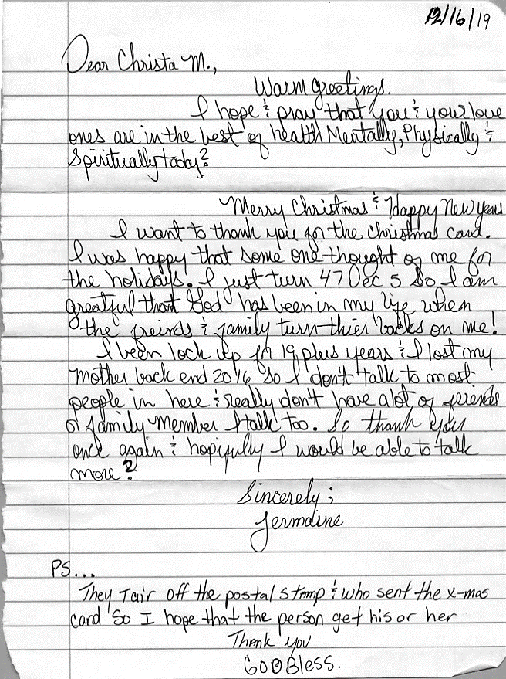
Our 2020
Fundraising campaign

REMEMBER ME
The writer of Hebrews urges believers to "Remember those in prison"(Hebrews 13:3). While society has shunned the prisoners, we will not.

Disciple of Christ Ministries boldly goes into the darkest places to shine the Light of the Gospel for others to see through our sub-ministry Pen Pals for Jesus.

At Disciple of Christ Ministries, we believe that there are three R's when ministering to prisoners:

Redemption: We believe that prisoners can be saved. Their crime does not disqualify them from salvation through faith which is in Christ Jesus.
Rehabilitation: We believe that destructive behaviors and distorted mindsets can be changed for good.
Restoration: We believe that prisoners can excel and be contributing citizens with the right guidance and encouragement.

To fulfill our mission to serve God’s people no matter where they are located. Your financial help is needed to fund our yearly budget of $4,250.00 for Our Pen Pals for Jesus Ministry in 2020

This does not include our local outreach for reentry support to individuals requesting our help.
Donations of any amount will help us bring the Gospel into the darkest places around the United States one prisoner at a time. You can make a donation by going to our website https://www.discipleofchristministries.org/make-a-donation/ or by sending a check to: Disciple of Christ Ministries,
273 Newport Ave Unit 2,
Quincy, MA 02170

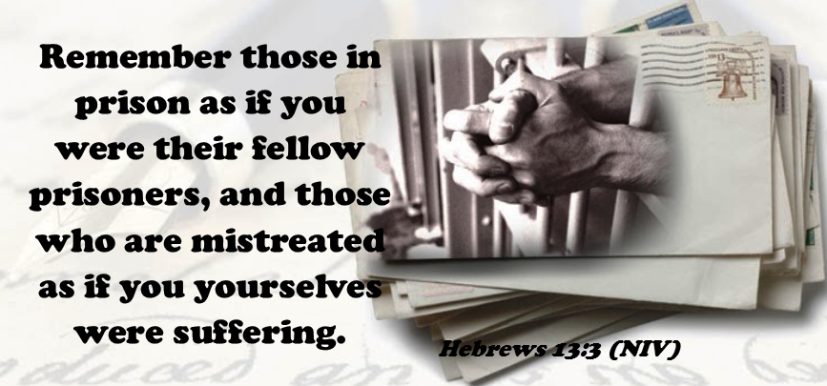

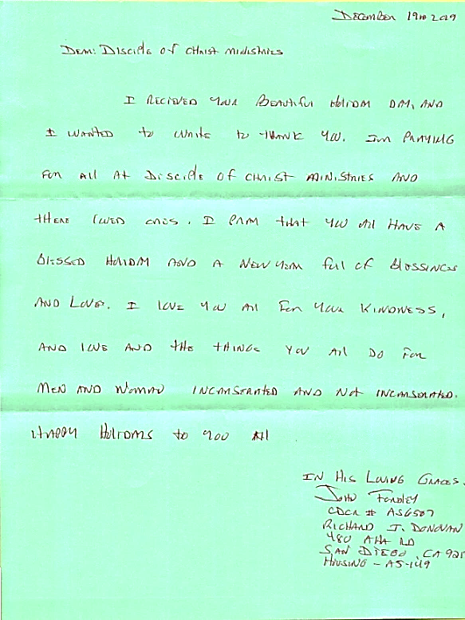

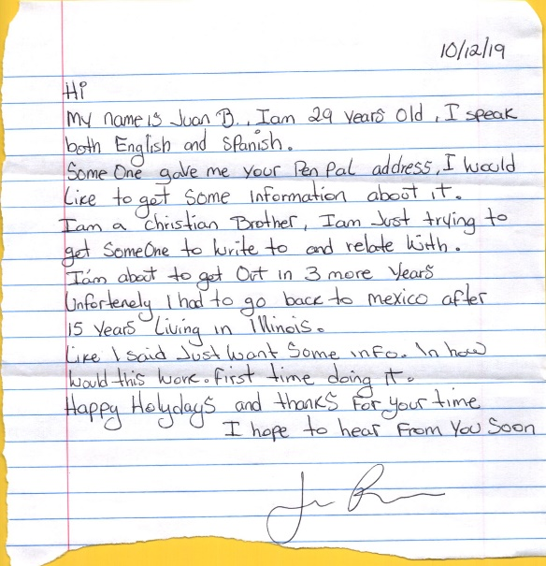

Sharing my story. So, others can find peace in sharing theirs.
Dennis Dockham
Founder Disciple of Christ Ministries
Ordained Christian Minister

As I was growing up we lived in the J.P. section of Boston then we moved to Dorchester while I was in 2nd grade. I lived through the forced bussing issues within the city of Boston as I attended Middle School, going on to be a student advocate while in High School. I was always getting involved in serving others and volunteering in many organizations throughout my twenties.

Married April 1989, moved to Quincy, MA, where I fathered my son in 1993 and my daughter in 1996. Still given a lot of time to helping others through different organization, I started to drift away from serving people, to how great I was. As my life became more business orientated and I grew into middle management so did my principles, No longer a servant but a self-centered arrogant money hungry person. My life started to be unmanageable and alcohol, gambling, and pornography became part of my daily routine quickly falling into addiction of earthy ways. Then in February 2006, I was arrested as a direct result of my alcohol and pornography use.

Over the next 2 years of court proceedings, divorce, and giving up on life, I was ready to throw in the towel and began praying to the God I was told had no use for me. Pleading nightly to take my life away and end my pain. Once again being selfish, only caring about my pain, not anyone else’s pain. In April 2008 I was sentenced to 5 years in the House of Correction, my life was over and my eyes covered by scales.

Once incarcerated, I started looking for God, and asking why He did not take my life that I prayed for so many nights over the 2 years of my court proceedings. I had hit rock bottom, what I thought was lowest type of person: a sentenced criminal, ending up in a place I never thought I would ever be, “in jail”. After the shock of being in jail that 1st week I fell to my knees and cried out to God asking for answers of how this could be, then for the very first time I felt a presence upon me. I heard “come to Me and give yourself over to me, and I will stand with you.” At first I was scared, and did not understand the things that started to come to me in visions and thoughts, some I still cannot explain today.

As I started to search my deepest thoughts, I picked up a Bible and joined a Bible Study group that was run by a Christian brother who had been coming into the jail for well over 10 years. I started to understand more of what the feelings I had within me were and how they affected my earthly ways living in the flesh.

Now seeing the changes I needed to make in my life, but how could I do this myself, me the self-centered, arrogant, thinking I was better than everyone else? Well God knew what he was doing placing me right where I needed to be at this point in my life, and that has forever changed my life as I came to know Jesus as my Lord and Savior. That He died on a cross for a sinner like me, undeserving of what He had done on the cross, so I could live with Him in eternity.

I realized that without God in my life, I would always be the same. So once again, I fell to my knees, this time to turn my life over to Christ asking for His forgiveness and seeking His wisdom, becoming born-again on Oct 27, 2008, on this day, I really felt His presence within my soul and my eyes became open to the Light of Christ. This was the start of an ever-changing way, that would become my daily walk with Christ and life changing ways of living.

Since my release November 2011, from the House of Correction, I have taken the wisdom of God’s Word and put it into practice in my daily walk, being obedient in serving my Lord and Savior, humbly serving those who are out there lost and shackled in bondage. Sharing my story of a broken, unwanted, despised individual who only thought the way out was death. Now in full repentance, seeking truth and striving to walk in the Light of Christ, surrendering all my faults over to God daily, praying for those fleshly behaviors to never return in my life.

Allowing the Holy Spirit to direct and guide me I proclaimed my faith in the power of resurrection by a Full Immersion Baptism on March 25, 2012 confessing to all my rebirth in Christ as written in scripture. Praising God every night for my salvation from my sins and for His daily guidance He provided to me through prayer and meditation time.

Remember I mention about pleading to God to take my life. Well, I am happy that God saw and had different plans for me. Yes, God took my life as I surrender to his calling not my own. I became a new creation in Christ Jesus, humbly living my life as a faithful servant. Striving to glorify God in everything I do, using my God given gifts, reaching out to the lost and forgotten through a ministry put upon my heart by God in a vision while still incarcerated. By having the faith in Christ, the foundation were formed in June 2012. Currently serving over 350 inmates in 37 States across the United States through our Pen Pals for Jesus Ministry.

I shared some of my darkest moments not for anyone’s judgment but transparency in the work of God in my life today. My faith only builds on my honesty with Jesus and those around me.

Jesus replied, ‘Truly I tell you, whatever you did not do for one of the least of these, you did not do for me.
Matt 25:45 (NIV)

273 Newport Ave Unit 2
Quincy, MA 02170-1727

How to Get Out of Your Comfort Zone

By Amy Weimer
From the series Daily Series

Have you ever been so warm in your bed in the morning that you never want to get out? Talk about a “comfort zone.” Now, say you had to get out for something good…like a great smelling breakfast wafting through the doors. That would be some incentive. But say what awaited you wasn’t so pleasant: something mundane like laundry or cleaning. But what’s worse, say what awaited you was something tortuous: like running into a fire or jumping into an ice-cold pool. Wouldn’t be so alluring to get out of your warm, comfortable bed, would it?

Now you have a small glimpse of what Jesus did for you. The Bible says that He was seated in heaven with God, His Father, with every heavenly luxury. He enjoyed a perfect and intimate relationship with God; all the angels bowed at His command; and He lived in Paradise. But Jesus chose to come down to Earth: dirty, sinful, painful Earth, filled with messed-up humans and limitations. He chose to leave glorious Heaven and come to messed-up Earth because He so deeply loved everyone who had gone astray. John 3:16 says, “For God so loved the world, that He sent His only begotten Son, that whoever believes in Him should not perish.” Jesus sacrificed His own comfort so that we could have our sins paid for.

What is on the other side of your comfort zone? Is it the person at the store who needs some encouragement? Is it the lonely girl in your class who no one wants to talk to? Maybe it’s the needy people around the world who could benefit from the sacrifice of your finances. It could be anything or anyone; but one thing is sure: there is someone who could benefit from you stepping out of your comfort zone. My life was radically changed because a girl in my Spanish class was willing to go to a college she didn’t want to but felt God call her to. And she reached out to a girl who had tons of problems and wasn’t always appreciative. But because she sacrificed her comfort, my life has been forever changed.

Who could you help by stepping outside of your comfort zone? It’s not easy to spend our time, energy, or words when it feels uncomfortable or inconvenient. But someone’s entire life could be bettered by it. Let us know how you are stepping out of your comfort zone or how you have been helped by someone else.

