September 2017

Freedom in Christ
Galatians 5:1-12 NIV
1 It is for freedom that Christ has set us free. Stand firm, then, and do not let yourselves be burdened again by a yoke of slavery. 2 Mark my words! I, Paul, tell you that if you let yourselves be circumcised, Christ will be of no value to you at all. 3 Again I declare to every man who lets himself be circumcised that he is obligated to obey the whole law. 4 You who are trying to be justified by the law have been alienated from Christ; you have fallen away from grace. 5 For through the Spirit we eagerly await by faith the righteousness for which we hope. 6 For in Christ Jesus neither circumcision nor uncircumcision has any value. The only thing that counts is faith expressing itself through love. 7 You were running a good race. Who cut in on you to keep you from obeying the truth? 8 That kind of persuasion does not come from the one who calls you. 9 “A little yeast works through the whole batch of dough.” 10 I am confident in the Lord that you will take no other view. The one who is throwing you into confusion, whoever that may be, will have to pay the penalty. 11 Brothers and sisters, if I am still preaching circumcision, why am I still being persecuted? In that case the offense of the cross has been abolished. 12 As for those agitators, I wish they would go the whole way and emasculate themselves!

Life by the Spirit
Galatians 5:13-26 NIV
13 You, my brothers and sisters, were called to be free. But do not use your freedom to indulge the flesh; rather, serve one another humbly in love. 14 For the entire law is fulfilled in keeping this one command: “Love your neighbor as yourself.” 15 If you bite and devour each other, watch out or you will be destroyed by each other. 16 So I say, walk by the Spirit, and you will not gratify the desires of the flesh. 17 For the flesh desires what is contrary to the Spirit, and the Spirit what is contrary to the flesh. They are in conflict with each other, so that you are not to do whatever you want. 18 But if you are led by the Spirit, you are not under the law. 19 The acts of the flesh are obvious: sexual immorality, impurity and debauchery; 20 idolatry and witchcraft; hatred, discord, jealousy, fits of rage, selfish ambition, dissensions, factions 21 and envy; drunkenness, orgies, and the like. I warn you, as I did before, that those who live like this will not inherit the kingdom of God. 22 But the fruit of the Spirit is love, joy, peace, forbearance, kindness, goodness, faithfulness, 23 gentleness and self-control. Against such things, there is no law. 24 Those who belong to Christ Jesus have crucified the flesh with its passions and desires. 25 Since we live by the Spirit, let us keep in step with the Spirit. 26 Let us not become conceited, provoking and envying each other.
273 Newport Ave Unit 2, Quincy, MA 02170 ~ Phone: 617-237-9607 ~ Email: Office@DiscipleofChristMinistries.org

Disciple of Christ Ministries

Pen Pals for Jesus

Our Newsletter

"THE EPISTLE TO THE GALATIANS"
Chapter Five
OBJECTIVES IN STUDYING THIS CHAPTER

1) To see that liberty in Christ does not mean license to do whatever we want.

2) To understand how one might be separated from Christ, and fall from grace.

3) To appreciate the need to walk in the Spirit, and the true evidence of one led by the Spirit.

SUMMARY

With verse one Paul reaches the climax of this epistle, stating what can properly be called the theme of his letter: "Stand fast therefore in the liberty by which Christ has made us free, and do not be entangled again with a yoke of bondage." He follows with dire warnings about the consequences of seeking to be circumcised and justified by the Law. He then reminds them that the hope of righteousness is for those who through the Spirit eagerly wait for it with a faith working through love (v1-6).

The next few verses continue with warnings about allowing others to hinder their progress, with Paul's harshest words reserved for those trying to impose circumcision. Yet Paul does not want anyone to think that liberty in Christ means license, and encourages them to use their liberty in order to serve one another in love. The two-fold benefit of this proper use of liberty is that one actually fulfills the Law, and at the same time does not give the flesh an opportunity to cause them to bite and devour one another. (v7-15).

Paul then stresses the need for the Christian to walk in the Spirit so as not to fulfill the lust of the flesh. He describes the enmity between the flesh and the Spirit, explaining why we must bear the fruit of the Spirit instead practicing the works of the flesh. Not only is there no inheritance in the kingdom of God for those engaging in the works of the flesh, but those in Christ have crucified the flesh with its passions and desires. Having been made alive in the Spirit, they ought to walk in the Spirit so as not to be conceited, not provoking nor envying one another (v16-26).

OUTLINE

I. A LIBERTY THAT EXCLUDES THE NECESSITY OF CIRCUMCISION (v1-6)

A. STAND FAST IN THE LIBERTY CHRIST HAS MADE POSSIBLE (1)
1. A call to stand strong in the freedom we now have in Christ (v1a)
2. A plea not to be entangled again with a yoke of bondage (v1b)

B. CIRCUMCISION IS NO LONGER NECESSARY (v2-4)
1. If one is circumcised out of a belief it is necessary, Christ will profit you nothing (v2)
2. Observing circumcision as a necessity requires keeping the whole law (v3)
3. Attempting to be justified by the Law will separate you from Christ and you will thereby fall from grace (v4)

C. THE BASIS FOR OUR HOPE OF RIGHTEOUSNESS (v5-6)
1. Through the Spirit and by faith, we eagerly wait for the hope of righteousness (v5)
2. Circumcision is inconsequential; what avails is faith working through love (v6)

II. A LIBERTY THAT FULFILLS THE LAW (v7-15)

A. A WARNING ABOUT THOSE WHO WOULD BIND THE LAW (v7-12)
1. Despite a good start, they were being hindered and it did not come from God (v7-8)
2. Beware of the influence of "a little leaven" (v9)
3. Paul is confident the Galatians will come around, and that the Lord will judge the trouble makers (v10)
4. A reminder that Paul himself was not preaching circumcision, with a strong condemnation of those who were troubling them (v11-12)

B. A PROPER USE OUR LIBERTY WILL FULFILL THE LAW (vv13-15)
1. Use our liberty to serve one another in love, and the Law will be fulfilled (v13-14)
2. Abuse your liberty, and it will be an opportunity to consume one another! (v13b, 15)

III. A LIBERTY IN WHICH ONE IS TO BE LED BY THE SPIRIT (v16-26)

A. WE MUST WALK IN THE SPIRIT (v16-18)
1. Only then will we not fulfill the flesh, which is contrary to the Spirit (v16-17)
2. If we are led by the Spirit, we are not under the Law (v18)

B. THE WORKS OF THE FLESH VS. THE FRUIT OF THE SPIRIT (v19-23)
1. The works of the flesh...
a. Identified by Paul (v19-21a)
b. Will keep one from inheriting the kingdom of God (v21b)
2. The fruit of the Spirit...
a. Identified by Paul (v22-23a)
b. Against which there is no law (v23b)

C. THOSE WHO ARE CHRIST'S ARE TO WALK IN THE SPIRIT (v24-26)
1. For they have crucified the flesh with its passions and desires (v24)
2. For they live in the Spirit (v25)
3. Therefore they should not be conceited, provoking and envying one another (v26)

REVIEW QUESTIONS FOR THE CHAPTER

1) What are the main points of this chapter?
- A liberty that excludes the necessity of circumcision (v1-6)
- A liberty that fulfills the Law (v7-15)
- A liberty in which one is to be led by the Spirit (v16-26)

2) What does Paul enjoin which serves as the theme of this epistle? (v1)
- Stand fast in the liberty in which Christ has made us free

3) What are two consequences of becoming circumcised in order to be saved? (v2-3)
- Christ will profit you nothing
- You become a debtor to keep the whole Law

4) What two things happen when one seeks to be justified by the Law? (v4)
- You become estranged from Christ
- You fall from grace

5) How are we to eagerly wait for the hope of righteousness? (v5)
- Through the Spirit, by faith

6) What truly avails something in Christ Jesus? (v6)
- Faith working through love

7) What saying did Paul use to illustrate the danger of the false teachers? (v9)
- A little leaven leavens the whole lump

8) What did Paul wish those who were so bent on enforcing circumcision would do? (v12)
- Even cut themselves off

9) What would be a misuse of our liberty in Christ? How should we use it instead? (v13)
- As an opportunity for the flesh
- To serve one another through love
What Spiritual Fruit Looks Like
“But he who received seed on the good ground is he who hears the word and understands it, who indeed bears fruit and produces: some a hundredfold, some sixty, some thirty.”
—Matthew 13:23
The concept of bearing fruit is used often in Scripture. In the Gospels, Jesus told the story of a sower who went out to sow seed. The seed fell on various types of ground. Some of the ground was rocky and hard. Other ground was receptive, but weeds choked out the seed. But there was a portion of ground that was not rocky or weedy, and the seed took root. Jesus said that this was a picture of the different people who hear the gospel. Those who are true believers are those who bring forth fruit (see Luke 8:4–15).
What is bearing fruit? Essentially, it is becoming like Jesus. Spiritual fruit will show itself in our lives as a change in our character and outlook. As we spend time with Jesus and get to know Him better, His thoughts will become our thoughts. His purpose will become our purpose. We will become like Jesus.
The Bible gives an excellent description a life characterized by the fruit of the Spirit. Galatians 5:22–23 says, “But the fruit of the Spirit is love, joy, peace, longsuffering, kindness, goodness, faithfulness, gentleness, self-control.”
Is that what others see in your life? If not, then either you don’t know God or you are living outside of fellowship with Him. If that is the case, then a commitment or a recommitment to Him would be in order. God is not asking for a perfect life. But He is asking that these fruits be primary characteristics of a life that is lived for Him.

10) What one command fulfills the Law? (v14)
- You shall love your neighbor as yourself

11) How does a Christian avoid fulfilling the lust of the flesh? (v16)
- By walking in the Spirit

12) If one is led by the Spirit, what is their relation to the Law? (v18)
- They are not under the Law

13) List the works of the flesh as described by Paul (v19-21)
- Adultery, fornication, uncleanness, licentiousness, idolatry, sorcery, hatred, contentions, jealousies, outbursts of wrath, selfish ambitions, dissensions, heresies, envy, murders, drunkenness, revelries, and the like.

14) What will be true of those who practice the works of the flesh? (v21)
- They will not inherit the kingdom of God

15) What elements constitute the fruit of the Spirit? (v 22-23)
- Love, joy, peace, longsuffering, kindness, goodness, faithfulness, gentleness, self-control.

16) What have those who are Christ's done? (v24)
- They have crucified the flesh with its passions and desires

17) If one lives in the Spirit, what is expected of them? (v25)
- To walk in the Spirit

18) How would people manifest that they are walking in the Spirit? (v26)
- By not being conceited, nor provoking or envying one another
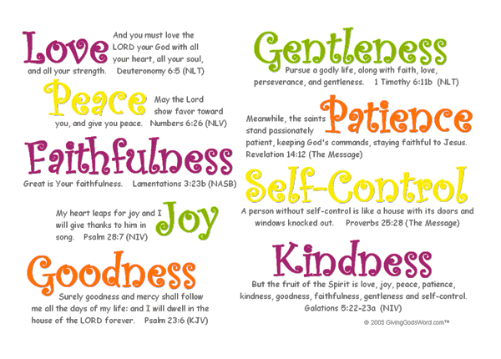

"Stewardship”

Stewardship involves the matter of your giving.
Three principles of stewardship: God owns it all! I have the responsibility to manage well what God owns. God wants me to give.

There are three ways to prompt giving:

- The Obligation way.
Have you ever felt obligated to give?
Illustration:
This kind of thing happens when you get an invitation from a co-worker to attend his fourth wedding. You hardly know the guy. You really don’t like him. But you feel obligated to go. And if you go you have to bring a gift. So, at the last minute, you rush out to Osco and snatch up a cheap toaster. On the way to the wedding, you wrap the toaster, minus the price tag. At the wedding, you give it to the co-worker and to the lady you wish you knew well enough to say, “What were you thinking?”
That is obligatory giving.
- The Manipulation way.
Illustration:
Someone once suggested a sure fire way to insure explosive giving: Just copy the state lottery system. The church would conduct the offering in the normal fashion. Then, when the ushers brought the offering plates to the front altar, the pastor would place all the offering envelopes in a big round tumbler. One usher would step forward and draw out one of the offering envelopes from the big round tumbler. The winner would receive DOUBLE THEIR MONEY BACK! Obviously, such pragmatism would make a mockery of God’s holiness.
- The Elation way.
This person is so excited, he just cannot wait to give. He needs no motivation. Illustration:
Several years ago, Bill Hare, a man in our church, approached his pastor and said, “Pastor, is it ever right to keep a secret from your wife? I bought a ring for my wife. It’s a half carat diamond. I don’t want to give it to her until it is totally paid for. I want to give it to her on our anniversary in two years.” Bill kept the ring a secret and made weekly payments until he had that ring paid off. He anxiously awaited the day to give it to Roxanne. He could not wait! Bill said, “Pastor, I have it all planned out how I’m going to give her the ring! We’re going to go to Pizza Hut. I’m going to have several other families from church there too. With everyone else around, I’m going to pull out the box and give her the ring! I can’t wait!” That’s exactly what he did! She was thrilled. Do you think Bill had fun with that gift? That is elation giving!

Read II Corinthians 9:7.
Every man according as he purposeth in his heart, so let him give; not grudgingly, or of necessity: for God loveth a cheerful giver.
Obligation equals “grudging.” Manipulation equals “of necessity.” Elation equals “cheerful.” It is a “Hilarious” giving. It involves excitement, “We’re having fun with this!”
Our church should never stoop to “obligatory giving.” Some churches send out letters informing members that their tithe is due and that if it is not received they can be expecting a visit. Neither should a church stoop to “manipulation giving.” Our church founders wisely wrote into our constitution that we would not have bake sales or pork dinners. We will not use gimmicks. We must love God so much and worship him so much that we cannot wait to give!
“Giving is preeminently an act of worship. It ought then to be a focal point of thanksgiving and self-dedication in weekly worship.” [4]

Donald Whitney tells of a friend in the construction business. This man avoided getting saved for years, because he said, “If I do they will always be hounding me to fix something for the church!” Well, guess what? He was dramatically saved, and he began seeing things that needed to be done. Without being asked he began repairing things all over the church and at the pastor’s home—without being asked! The same thing happened with his giving![5]

Why? He became a cheerful giver!
Your giving should be of three types.
Type One:
1. Tithing gifts
In I Corinthians 9 Paul answers two questions.
The first question is, “Is tithing really necessary?” Paul says, A soldier goes to war. Does he pay his own way? No. A farmer works all year long. Does he eat the fruit of his labor? Yes! A shepherd feeds his flock. Doesn’t he receive some benefit? Yes! Paul quotes Deuteronomy 25:4, Thou shalt not muzzle the ox when he treadeth out the corn. The ox has a right to necessary food. Do you expect him to do the work for nothing? No! The same is true of your church ministry.

[4] Richard B. Cunningham, “Principles and Procedures of Responsible Giving,” Resource Unlimited, ed. William L. Hendricks, (Nashville: The Stewardship Commission of the Southern Baptist
Convention, 1972), 233.
[5] Donald S. Whitney, Spiritual Disciplines Within the Church, (Chicago: Moody, 1996), 125.

The second question Paul addresses is whether the tithe is still applicable to the church. In verse 13 Paul describes the Old Testament system. The tithe was applied before the law was given. It was a part of the law in the O.T. as well.
1 Corinthians 9:13 – Do ye not know that they which minister about holy things live of the things of the temple (tithes)? and they which wait at the altar are partakers with the altar?
It is a clear Old Testament teaching that the first 10 percent went to God’s cause.
Two other Old Testament passages further enunciate the Biblical tithing position.
Read Proverbs 3:9,10. Honor the LORD with thy substance, and with the firstfruits of all thine increase: So shall thy barns be filled with plenty, and thy presses shall burst out with new wine.
Read Malachi 3:8.
Will a man rob God? Yet ye have robbed me. But ye say, Wherein have we robbed thee? In tithes and offerings.
Then Paul says in I Corinthians 9:14, Even so, or “In the same way,” hath the Lord ordained that they which preach the gospel should live of the gospel!
God’s way works! Unfortunately, many Christians have not had the faith or the willingness to obey God about the tithe.
Type 2

2. Grace gifts
In II Corinthians 8:1-5 Paul describes grace giving.
Read verses 1-5. Grace giving is giving above and beyond the tithe.
As you study this chapter, locate principles concerning “grace” giving. How many can you find?
1.

2.

3.

4.

5.

Third type of giving:

3. Faith gifts
Faith commitment involves giving beyond what you see possible to give.
Read II Corinthians 9:8. And God is able to make all grace abound toward you; that ye, always having all sufficiency in all things, may abound to every good work:
Read II Corinthians 9:11. Being enriched in every thing to all bountifulness, which causeth through us thanksgiving to God.
Only God can make this kind of giving happen. God is able! In financial matters, faith is not faith in if the decisions to give are determined by the means we “see.” We walk by faith, not by sight.
There are two reasons most do not give: Read Mark 10:17-22

Two Reasons:
- Materialism.
- Lack of faith

Luke 12:27-31
Consider the lilies how they grow: they toil not, they spin not; and yet I say unto you, that Solomon in all his glory was not arrayed like one of these. If then God so clothe the grass, which is to day in the field, and tomorrow is cast into the oven; how much more will he clothe you, O ye of little faith? And seek not ye what ye shall eat, or what ye shall drink, neither be ye of doubtful mind. For all these things do the nations of the world seek after: and your Father knoweth that ye have need of these things. But rather seek ye the kingdom of God; and all these things shall be added unto you.
Illustration:
A little girl named Shannon earned an extra ten dollars from her Grandad for some odd jobs that she had done. She came home from church the next Sunday and informed her parents that she put in her regular offering plus the ten dollars that she had earned. Her mom mentioned to her that Christmas was coming and that she needed to make sure she had enough saved for that.
Shannon’s faith put all doubting adults to shame when she said, “Oh, I’m not worried about that. My daddy will make sure I have enough for Christmas presents.” And your Heavenly Father will make sure you have enough to give, too. You need the faith of a child to have the faith to give.
How often have we been prompted by the Holy Spirit to give extra to a special cause, only to say, “I can’t afford to give that. I have other things I need to save for.” We need to exercise the faith to say, “My father in heaven will make sure I have enough.”
Study Questions:
- List two inappropriate reasons to give.

- What is the only reason to give?

- List the three types of giving.

- What are the two reasons most do not give?

From the Desk of Brother Doc
Well, it has been a busy summer for me personally, many changes have happened since the last newsletter that have taken me through some trials and tribulations. Life is hard and we need to always keep Jesus in our daily walk. No matter how hard and bad the situation is God will see you through it, if you let Him.

On Wednesday June 21st I lost not only my Uncle Bill I lost a mentor, a best friend, a spiritual teacher, a faithful servant, and a father figure to me since 1976 when my own Dad passed. I was so blessed to be able to be there for him during his battle with cancer the past 4 1/2 years.

The last year being the hardest on him with all the medical issues he faced that took his quality of life away. As some of you know, Bill never complained about his pain and never wanted to burden his family in anyway. A fighter to the very end not wanting to let anyone to do things for him, as he was so independent and self-sufficient.

One of his best qualities that helped me become the person I am today is his faith in Christ, and that no matter what was going on in his life Bill would say God would not give me anything more than I could handle. Bill was not just talking about himself he was talking about every one of us who went to him with our own trouble. Not just family but so many others individuals who had struggles in living life on life's terms.

Many looked to Bill for guidance as he was a positive example of stewardship; using his God given gifts to the best of his ability, selflessly serving others. Over the past 2 months, I have heard so many stories of how Bill helped individuals by his friends in AA. (Bill had 29 years of sobriety 1 day at a time)

A biblical world view of stewardship can be consciously defined as: "Utilizing and managing all resources God provides for the glory of God and the betterment of His creation."^{[2]} The central essence of biblical world view stewardship is managing everything God brings into the believer's life in a manner that honors God and impacts eternity.

I have had many conversations with my uncle Bill about his faith in God and that he was never alone as Christ was always with him. This gave me much comfort as I knew Bill was looking forward to be going home to be with God and understood that when the time came it was God's will for him to be lifted up to receive his treasures in Heaven.

My Uncle Bill is now in his glorified body and walking among the many saints that have already gone home to be with the Lord. I was very fortunate to be with him as he took his last breath here on earth and feel his soul lifting up to be with his Lord and Savior Jesus. I will leave you with the Holy Scripture I had shared with Bill many times during his last days. (John 14 1-4 NIV)

Jesus talking
“Do not let your hearts be troubled. You believe in God; believe also in me. My Father’s house has many rooms; if that were not so, would I have told you that I am going there to prepare a place for you? And if I go and prepare a place for you, I will come back and take you to be with me that you also may be where I am. You know the way to the place where I am going.”

Putting together this newsletter was somewhat hard as it was something my Uncle supported and always made sure I had the stamps to do the mailing. He would also ask how I was making out with putting it together until I finally said it was done and ready to mail out. I always shared the importance of it to share what God has placed upon my heart to all of you who receive the newsletter in prison.

I have also struggled a little on what my true calling is and what God has planned for my next stage of my life. Not having my uncle to care for anymore has given me a lot of time to reflect on my serving God, where and how. So to say the least I have spent a lot of time fasting and praying, seeking God direction.

One thing kept coming up as I meditated on the scripture: was I being a good steward of the gifts God has given me. Am I obedient to the calling of this ministry, am I doing everything God wants me to do in ministry If not what else can I do to be a better steward of the gifts I have been given by God?

As July and August passed by so did my thoughts of how to be a better servant of the gifts I have been given. Now I must follow up on my original calling and become the person God has called me to be: Faithful Servant, living a Godly life that includes being a Disciple of Christ sharing the Gospel to everyone who needs to hear it; just as it was shared to me during my time of feeling lost and forgotten. God wants to have a relationship with you, are you willing to allow Him into your life?

As I prepared for this newsletter, and having Stewardship on my mind, God placed the following scriptures upon my heart. Freedom in Christ - Galatians 5:1-12 and Life by the Spirit - Galatians 5:13-26 “Fruit of the Spirit”. I hope that you take this opportunity to find the gifts that God has given you and use them for Gods glory, not for your own. It is for freedom that Christ has set us free. Stand firm, then, and do not let yourselves be burdened again by a yoke of slavery. Seek God and live by the “Fruit of the Spirit”. “You, my brothers and sisters, were called to be free. However, do not use your freedom to indulge the flesh; rather, serve one another humbly in love.”

“So, walk by the Spirit, and you will not gratify the desires of the flesh. For the flesh desires what is contrary to the Spirit and the Spirit what is contrary to the flesh. They are in conflict with each other, so that you are not to do whatever you want. These acts of the flesh are obvious: sexual immorality, impurity and debauchery; idolatry and witchcraft; hatred, discord, jealousy, fits of rage, selfish ambition, dissensions, factions and envy; drunkenness, orgies, and the like. I warn you, as I did before, that those who live like this will not inherit the kingdom of God.”

Live by the fruit of the Spirit: love, joy, peace, forbearance, kindness, goodness, faithfulness, gentleness and self-control. Against such things, there is no law. Those who belong to Christ Jesus have crucified the flesh with its passions and desires. Live in Christ and be good stewards of the gifts He has given you.

What is bearing fruit? Essentially, it is becoming like Jesus. Spiritual fruit will show itself in our lives as a change in our character and outlook God is not asking for a perfect life. However, He is asking that these fruits be primary characteristics of a life that is lived for Him.

I understand, that some of you are saying well what can we do, we are in prison. God has and still does uses people in prison. All through the Bible, there are stories of
Individuals from Joseph to Paul who were major players in God’s arsenal who were imprisoned. They had great stewardship of the gifts God gave them and used them faithfully for His Kingdom.

Therefore, I challenge every one of my brothers & sisters to take time in your day and reflect on how you handled situations based on the fruit of the Spirit, take note how you can better serve God, and be good stewards of the gifts God has freely given you.

May your actions be like the Light of Christ to an individual who does not know Christ! You may be the closest thing to a Bible a person ever knew. May God bless you and give you the gifts he has already planned for you so you can glorify Him in everything you do.

Forever in His hands,
Dennis Dockham
Founder/Ordained Christian Minister
Up Coming Events
No Newsletter for October, November, or December as we prepare for the launch of our Christmas Card Outreach on November 1st 2017 it is my hope to exceed the past years of personalized Christmas Cards to not only our Pen Pals but to the families of our inmates who take part in our Pen Pals for Jesus Ministry.

Coming back in 2018 our Behind the Wall section of the Newsletter will be located here. This will be a place for our Pen Pal for Jesus participants to share what Jesus is doing in their lives. We invite you to send us those poems and artwork that you do, which is glorifying to God.

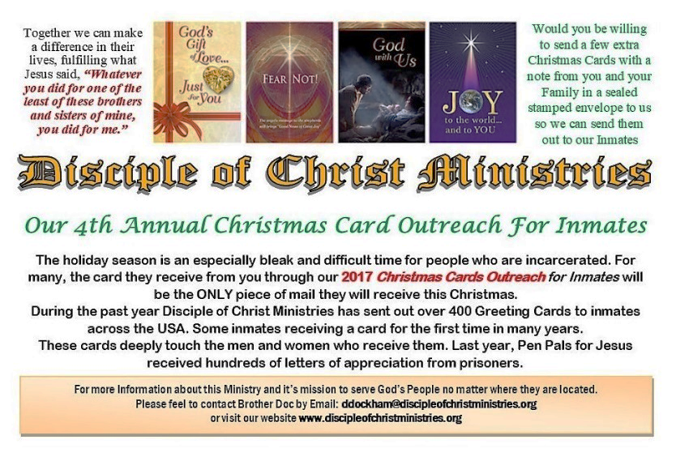

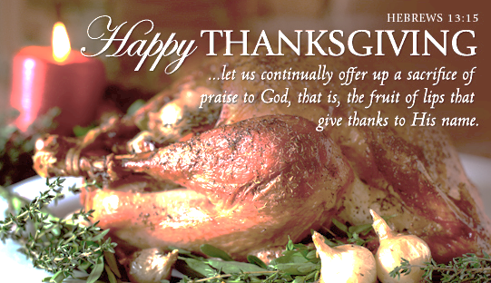

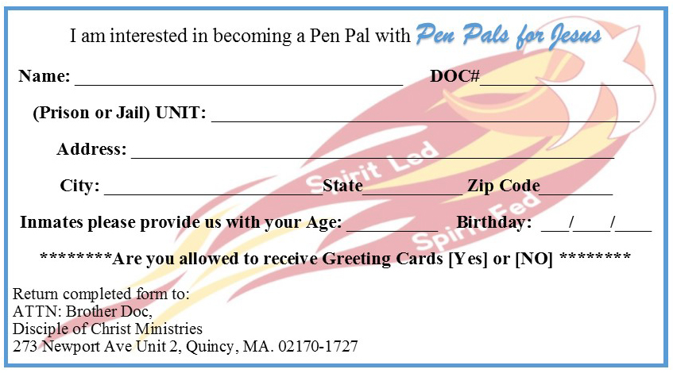
Pen Pals for Jesus is reaching out to the lonely men and women in prison. Most of the inmates contacting us have already accepted Jesus or they are seeking God. All of them are lonely, discouraged, and feel rejected, in need of a caring friend and Christian Fellowship.

We are in need of volunteers to write our Christian inmates who are seeking pen pals.

With over 235 request from brothers and sisters whom have fallen into dark times, and have turned to Christ for guidance and a better way to live their lives through the grace of Christ blood shed on the cross.

Disciple of Christ Ministries
Was founded with the belief that one person can make a positive change in those who are out there lost and living in the flesh. Our work built upon the following five pillars of faith:
- A duty to reach out to the lost and forgotten.
- An obligation to lead by example.
- An all-inclusive approach: We help everyone regardless of his or her religious beliefs.
- That the path to salvation lies in our Lord Jesus, serving Him in everything we do.
- That Christ will use our testimonies for His glory so others can see how God has taken our trials and tribulations and turned them into victories for Christ.
Jesus reply, ‘Truly I tell you, whatever you did not do for one of the least of these, you did not do for me. Matt 25:45 (NIV)

Our Mission
Our mission is to spread the gospel of Jesus Christ where we live, work, and through prison ministry.

How are we doing this?
- By developing a community of committed disciples of Jesus Christ, which will have an impact for Christ locally and around the world.

- Through personal evangelism, the sharing of our own testimony of how God has worked in our lives and the impact it has had on our personal relationships with Christ.
- By building a strong “Christian Fellowship” and a team of missionaries, who will be able to write to those who are seeking the Lord Jesus in their life, through our Pen Pals for Jesus Ministry! Thus, His sheep that have fallen into the ways of the flesh, giving them the same hope and faith that Christ has given to us so freely will know Christ.

- By developing a working outreach-mentoring program, which will be able to assist and help reintegrate those who are seeking a new and better life after incarceration.

- Building resources with local and state agencies, to better assist in getting a person the much-needed services they so desperately need, like clothing, food, medical services, and housing.
273 Newport Ave Unit 2
Quincy, Massachusetts 02170

“Answering the call to serve God’s People no matter where they are located”
Answering the call to serve God’s People no matter where they are located

